Pre and Post Course Survey Report:

Summary of Findings



C2C – Bridging the Gap from College to Careers

Disability and Professional Development







Submitted to SDSU Interwork Institute, PolicyWorks and Kessler Foundation

By,

Dr. Victor Pineda

World ENABLED

1

Summary of Findings

|  |  |  |
| --- | --- | --- |
| Construct | Before | After |
| Disability is an asset to employers | 31.6% | 90.9% |
| Feeling unprepared or not having a career plan | 51.6% | 10.7% |
| Able to Answer "what work do you hope for?" | 46.8% | 92.3% |
| Knowledge of workplace values | 34.6% | 76.3% |
| Feel comfortable in job interviews | 19.9% | 86.0% |
| Unequally treated vs Ask for accommodation |  | 87.6% |
| Comfortable working with people | 38.5% | 87.1% |
| Comfort with speaking about accomplishments | 24.2% | 87.1% |
| Comfort with sharing thoughts freely | 34.4% | 88.6% |
| Understanding what employer is looking for | 32.5% | 93.8% |
| Hard to get job with disability (yes) | 67.5% | 19.1% |
| Leadership skills are improving | 44.2% | 84.6% |
| Comfortable discussing needs with employer | 26.6% | 85.1% |
| Understand employer fears about hiring persons with  disabilities. | 28.2% | 94.6% |
| Knowledge of laws | 26.3% | 93.9% |
| Employer will want to hire me | 29.1% | 93.1% |
| Disability is a source of pride | 65.5% | 91.6% |

Please indicate the degree to which you agree or disagree with the following statements:

1. My disability can be an asset in my career.

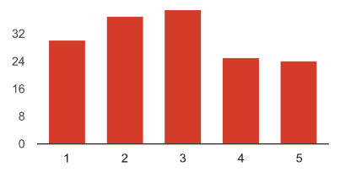

Disagree: 1

2

3

4

Agree: 5

1. As a result of this course, I now understand that a disability can be an asset in my career.

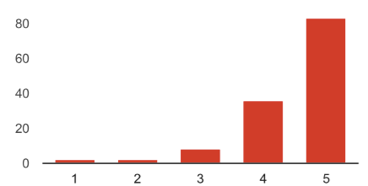

Disagree: 1

2

3

4

Agree: 5

Impact Analysis:

The construct being measured was “disability can be an asset.”

The percentage of people who either agree or strongly agree with this construct increased by 59.3% (from 31.6% before the course to

90.9% after the course).

2. I don't have a well thought out career plan.

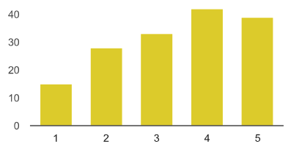

2. This course did little to help me plan out a career plan.

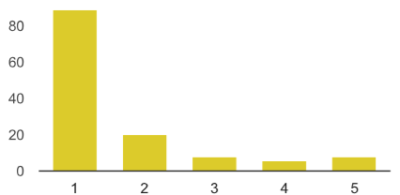

Disagree: 1

2

3

4

Agree: 5

Disagree: 1

2

3

4

Agree: 5

Impact Analysis:

The construct being measured was feeling unprepared or “not having a thought out career plan.”

The percentage of people who either agree or strongly agree with this construct DECREASED by 40.9% (from 51.6% before the course to 10.7% after the course).

This indicates that respondents showed an increase in the number who had career plans.

3. My family and friends often ask me, "what work do you hope to do for your career?"

Disagree: 1

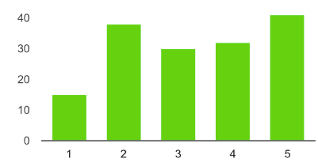

2

3

4

Agree: 5

3. As a result of this course, I feel more confident in answering the questions like "what work do you hope to do for your career?"

Disagree: 1

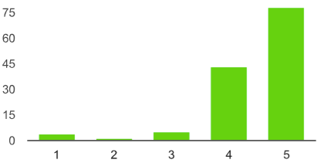

2

3

4

Agree: 5

Impact Analysis:

The construct being measured was different in pre and post survey, so these results should be assessed separately. Before the course 46.8% of respondents noted that their family and friends ask about their career plans.

After the course 92.3% felt confident to respond to these inquiries.

No comparison can be made from pre-post as these are separate constructs.

4. I have little knowledge of workplace values, cultures and practices.

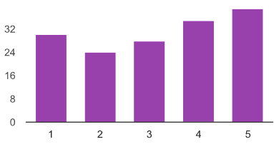

Disagree: 1

2

3

4

Agree: 5

4. The course did not help me gain knowledge of workplace values, cultures and practices.

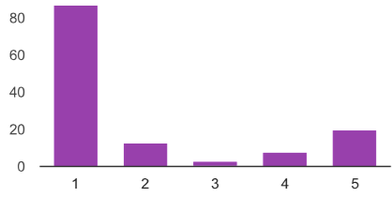

Disagree: 1

2

3

4

Agree: 5

Impact Analysis:

The construct being measured was “having knowledge of workplace values, cultures, and practices.”

The percentage of people who either disagree or strongly disagree with this construct increased by 41.7% (from 34.6% before the course to 76.3% after the course).

By disagreeing, respondents note that they have gained substantial insights into workplace values, cultures, and practices.

5. I feel uncomfortable during job interviews.

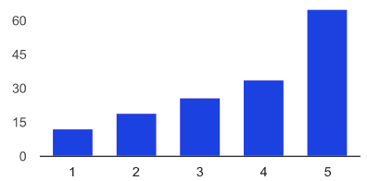

Disagree: 1

2

3

4

Agree: 5

5. As a result of this course, I feel more comfortable during job interviews.

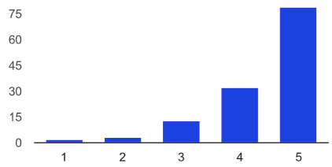

Disagree: 1

2

3

4

Agree: 5

Impact Analysis:

The construct being measured was “feeling comfortable during job interviews”

The percentage of people who either agree or strongly agree with this construct increased by 66.1% (from 19.9% who felt comfortable in interviews before the course to 86% who felt more comfortable with interviews after the course).

Note: The pre-survey question was inverted to match the post-course construct

6. During my previous work assignment (paid or volunteer) I felt like I was treated unequally relative to my peers.

Disagree: 1

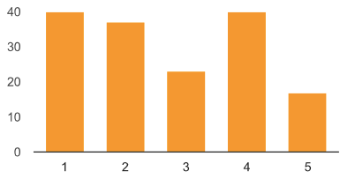

2

3

4

Agree: 5

6. As a result of this course I am more prepared to ask for reasonable accommodations.

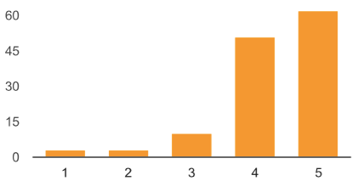

Disagree: 1

2

3

4

Agree: 5

Impact Analysis:

The construct being measured was different in pre-post survey and cannot be compared.

36.3% of respondents before the course said they were treated unequally.

87.6% of respondents after the course are more prepared to ask for reasonable accommodations.

7. I feel comfortable working/interacting with people I don’t know.

Disagree: 1

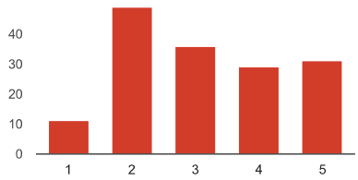

2

3

4

Agree: 5

7. As a result of this course, I feel more comfortable working/interacting with people I don’t know.

Disagree: 1

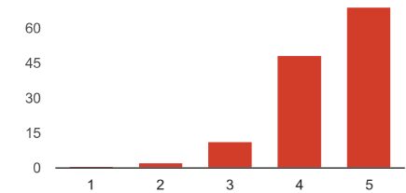

2

3

4

Agree: 5

Impact Analysis:

The construct being measured was “being at ease working/interacting with new people”

The percentage of people who either agree or strongly agree with this construct increased by 51.5% (from 38.5% before the course to

90% after the course).

Note: As a result of the course, an overwhelming majority (90%) of respondents feel more comfortable interacting with people they don’t know.

8. I don't feel comfortable telling new people about myself and my accomplishments.

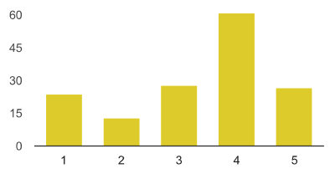

Disagree: 1

2

3

4

Agree: 5

8. As a result of this course I feel more comfortable telling new people about myself and my accomplishments.

Disagree: 1

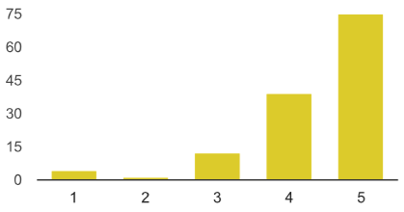

2

3

4

Agree: 5

Impact Analysis:

The construct being measured was “feeling comfortable telling new people about yourself and your accomplishments”

The percentage of people who either agree or strongly agree with this construct increased by 62.9% (from 24.2% before the course to

87.1% after the course).

Note: The pre-survey question was inverted to match the post-course construct “feeling comfortable about telling new people about yourself and your accomplishments.”

9. I don't feel comfortable sharing my thoughts.

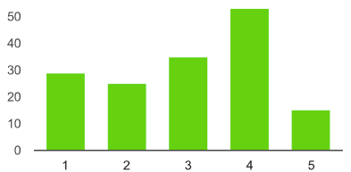

Disagree: 1

2

3

4

Agree: 5

9. As a result of this course, I feel more comfortable sharing my thoughts.

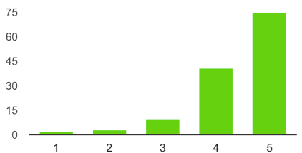

Disagree: 1

2

3

4

Agree: 5

Impact Analysis:

The construct being measured was “feeling comfortable sharing one’s thoughts”

The percentage of people who either agree or strongly agree with this construct increased by 54.2% (from 34.4% before the course to

88.6% after the course).

Note: The pre-survey question was inverted to match the post-course construct

10. I understand what an employer is really looking for in a potential job candidate.

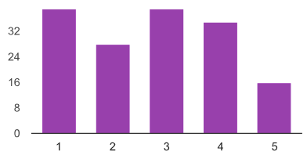

Disagree: 1

2

3

4

Agree: 5

10. As a result of this course, I have a better understanding of what an employer is really looking for in a potential job candidate.

Disagree: 1

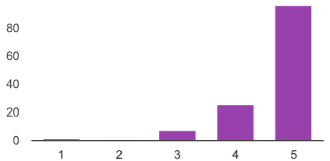

2

3

4

Agree: 5

Impact Analysis:

The construct being measured was “understood what an employer looks for in a potential job candidate”

The percentage of people who either agree or strongly agree with this construct increased by 61.3% (from 32.5% before the course to

93.8% after the course).

11. Obtaining employment after graduation will be harder for me than for my peers.

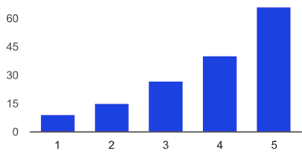

Disagree: 1

2

3

4

Agree: 5

11. I still think that obtaining employment after graduation will be harder for me than for my peers.

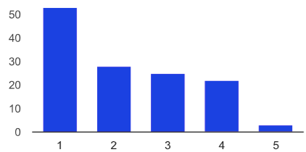

Disagree: 1

2

3

4

Agree: 5

Impact Analysis:

The construct being measured was “obtaining employment will be more difficult than my peers”

The percentage of people who either agree or strongly agree with this construct decreased by 48.4% (from 67.5% before the course to

19.1% after the course).

Note: Although 19.1% still feel that “obtaining employment will be more difficult for them than their peers” other measures note that students overall felt more prepared to address the perceived difficulties that ahead (for example asking for reasonable accommodations Q6).

12. Relative to my peers, my leadership skills are strong and improving.

Disagree: 1

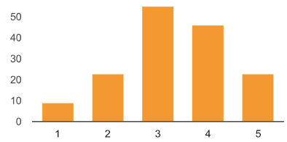

2

3

4

Agree: 5

12. Relative to my peers, my leadership skills are strong and improving.

Disagree: 1

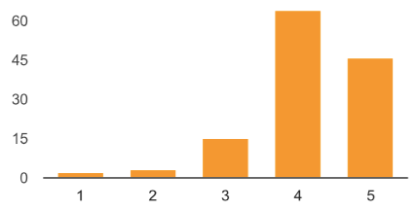

2

3

4

Agree: 5

Impact Analysis:

The construct being measured was “my leadership is strong and improving”

The percentage of people who either agree or strongly agree with this construct increased by 40.4% (from 44.2% before the course to

84.6% after the course).

13. I feel confident discussing my disability related needs to a potential employer, supervisor or co-worker (assuming you have a disability).

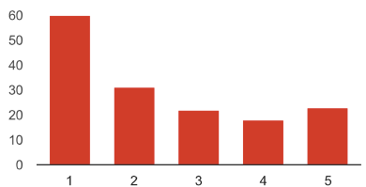

Disagree: 1

2

3

4

Agree: 5

13. I feel more confident discussing my disability related needs to a potential employer, supervisor or co-worker (assuming you have a disability).

Disagree: 1

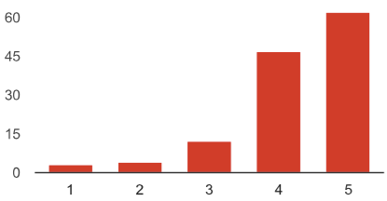

2

3

4

Agree: 5

Impact Analysis:

The construct being measured was “confidence in discussing one’s disability”

The percentage of people who either agree or strongly agree with this construct increased by 58.5% (from 26.6% before the course to

85.1% after the course).

14. I understand an employer’s fears about hiring a person with a disability and I am prepared to respond effectively.

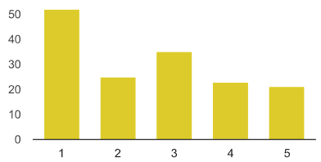

Disagree: 1

2

3

4

Agree: 5

14. As a result of participating in this course, I understand an employer’s fears about hiring a person with a disability and I am prepared to respond effectively.

Disagree: 1

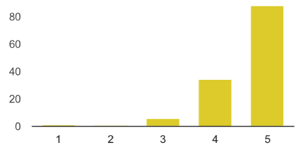

2

3

4

Agree: 5

Impact Analysis:

The construct being measured was “understood employer’s fears of hiring a PWD and one’s preparedness to response effectively”

The percentage of people who either agree or strongly agree with this construct increased by 66.4% (from 28.2% before the course to

94.6% after the course).

15. I know about disability employment nondiscrimination laws and the history of the employment of people with disabilities in the USA.

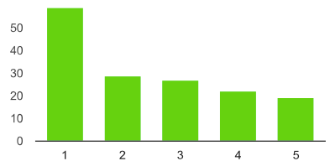

Disagree: 1

2

3

4

Agree: 5

15. I know about disability employment nondiscrimination laws and the history of the employment of people with disabilities in the USA.

Disagree: 1

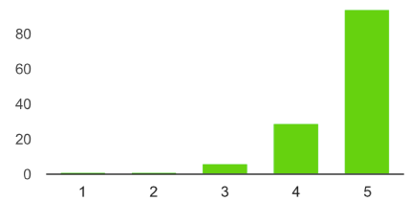

2

3

4

Agree: 5

Impact Analysis:

The construct being measured was “knowledge about employment non-discrimination laws and history of employment of PWD in

USA”

The percentage of people who either agree or strongly agree with this construct increased by 67.6% (from 26.3% before the course to

93.9% after the course).

16. I am confident that an employer will want to hire me.

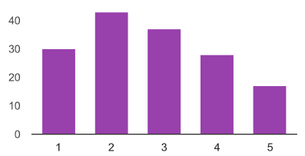

16. I am confident that an employer will want to hire me.

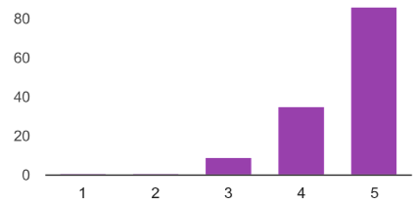

Disagree: 1

2

3

4

Agree: 5

Disagree: 1

2

3

4

Agree: 5

Impact Analysis:

The construct being measured was “confidence that oneself will be wanted to be hired”

The percentage of people who either agree or strongly agree with this construct increased by 64% (from 29.1% before the course to

93.1% after the course).

17. I am proud of being a person with a disability.

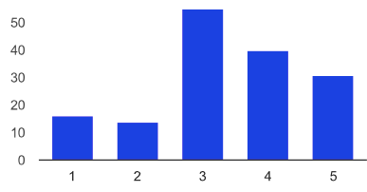

17. I am proud of being a person with a disability.

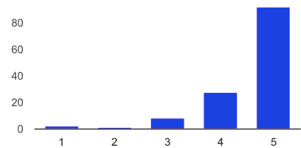

Impact Analysis:

The construct being measured was “being disabled and proud”

Disagree: 1

2

3

4

Agree: 5

Disagree: 1

2

3

4

Agree: 5

The percentage of people who either agree or strongly agree with this construct increased by 46.1% (from 45.5% before the course to

91.6% after the course).

# Excerpts from Student Testimonials

## PROFESSIONAL DEVELOPMENT AND DISABILITY

### California State University at Fullerton and University of California Berkeley 2015-2016

 Thank you so very much for this course. It was, without a doubt, the course that will have the most impact on my career. I am grateful to you for all the time and energy you put into the development of the course, the speakers and the assignments. I have enjoyed these past 15 weeks immensely. And the things I have learned here I will take with me the rest of my life. I am very grateful.

 At the conclusion of your class, you encouraged me in my speaking-up (bragging) and offered to write me a letter of recommendation in the future. Just a little over a semester from now I will be walking at commencement, and I am applying to be the student commencement speaker at my college's (CNR) ceremony because of the skills I learned in this class.

 I keep think about Peggy Klaus and what she taught us. It was transformational. I’ll never be the same. I’ll always be proud and confident. Thanks to the both of you! The insights you shared were extremely valuable. I could not agree more with your comment on the imperative coexistence of both disability rights along with disability responsibilities. I would love to share some of the information you address with the parents and youth with disabilities back in the Southern California Los Angeles area where I come from. I think that high school youth with disabilities along with their parents need to understand and hear the realities associated with employment, the future of the benefits system, as well as their own personal responsibilities and their futures.

 Thanks for all your support! I did go through final round interviews with Apple. I don't have a written offer letter yet, but the recruiter gave me indication that they will extend an offer and they're working on the terms. I'm also going through the interviewing process with Google for a very different role. So at this point I think I probably will be accepting an offer within the next few weeks. Thanks again for all your help in my job search!

 This class offered me insight into how my disability can help me get a job. It gave us useful tips and strategies in order to get the job we want.

 This course taught me about a lot of disability resources that I didn’t know about or would have ever found looking around on my own. The job hunt, interview and employment process is certainly different for pwd’s and other than it is for others. Other than this course, there isn’t a lot out there to guide us. This course fills a void of information and direction on the subject. For example, how to manage your disability in an interview was a new idea and very helpful to me. This was a really great class. What a great idea to actually help students with disabilities prepare more deeply and completely for their careers. The information was fundamentally important and represents a missing link in our transition process.