GRADUATE STUDENT HANDBOOK

Master of Science Degree in Rehabilitation Counseling

SAN DIEGO STATE UNIVERSITY
Department of Administration, Rehabilitation
& Postsecondary Education

Department and Program Address:

Rehabilitation Counseling Program
San Diego State University
Department of Administration, Rehabilitation, and Postsecondary Education
College of Education
5500 Campanile Drive
San Diego, CA 92182-1154

(619) 594-6406 (V/TTY)
http://interwork.sdsu.edu/main/rcp

Fall 2014

". . . I feel the capacity to care is the thing which gives life its
deepest significance."

- Pablo Casals

WELCOME

Welcome to the Rehabilitation Counselor Program (RCP) at San Diego State University! We are pleased that you have chosen to study with us and hope the time you spend here will be rewarding and enjoyable. The Rehabilitation Counselor Program at San Diego State University (SDSU) was established in 1972. Its administrative location is in the Department of Administration, Rehabilitation, and Postsecondary Education in the College of Education. The Program is supported, in part, by training grants from the U.S. Department of Education, Office of Special Education and Rehabilitative Services, Rehabilitation Services Administration.

This Handbook includes information and guidelines that will be very helpful to you as you pursue your degree. Please follow the guidelines and keep in touch with Leesa Brockman, the Program's Academic Coordinator, regarding your schedule and course of study during the time you are completing your Master of Science degree.

Advising
Leesa Brockman, the Academic Coordinator for the program will advise you on general questions of status and procedures that will enable you to progress through the program and graduate. You may make appointments with her at 619-594-6406 or lbrockman@interwork.sdsu.edu to fill out changes of status, file official programs, and or make program additions, deletions, or changes.

Every student will be assigned to a full-time faculty member for academic advising. If you have questions regarding a particular area of interest in the rehabilitation counseling field, questions about your career goals and direction, or to determine the scope and sequence of courses, please make an appointment with your faculty advisor. Your faculty advisor will help you in planning the sequence of courses to complete the RCP as effectively as possible to meet your academic and career goals.

We hope your graduate experience will be both pleasant and productive.

MISSION and VISION STATEMENTS

Underlying all of the academic and externally funded projects based at the Interwork Institute, including the Rehabilitation Counselor Program, are the following mission and vision statements:

Interwork’s core mission is to enable individuals, organizations and communities to support, appreciate, and engage diverse members in community integration through education, research, and advocacy.

Our Vision is to accomplish through development of exceptional leaders in diverse educational and human service organizations using innovative and effective learner opportunities and cross-functional strategic alliances.

Please visit our website at http://interwork.sdsu.edu/main/rcp for more information.

GOALS AND OBJECTIVES

The Goal of the RCP at SDSU is to:

Prepare graduate trained rehabilitation counselors (qualified rehabilitation personnel) to provide vocational rehabilitation services which result in effective community adjustment with individuals with disabilities who are seeking, securing, and/or maintaining effective employment and community integration.

Six essential principles operationalize this Goal:

1. The student shall assess his/her personal qualities and develop and implement an individual plan for growth and improvement through ARP 615 (Multicultural Dimensions in Counseling); ARP 684 (Rehabilitation Foundations); ARP 645A/B (Assessment and Career Development); and ARP 685A/B (Medical and Psychological Aspects of Disability).

2. The student shall develop and demonstrate the effective interpersonal skills of a rehabilitation counselor through ARP 615 (Multicultural Dimensions in Counseling); ARP 660 (Theory and Process of Counseling); ARP 648 (Group Dynamics in Rehabilitation); ARP 687 (Placement with Individuals with Disabilities); ARP 607 (Applications of Rehabilitation Technology), ARP 744 (Practicum in Rehabilitation); and ARP 745 (Internship in Rehabilitation).

3. The student shall understand the effective administration of rehabilitation programs from a humanistic and cost-effective perspective through ARP 684 (Rehabilitation Foundations); ARP 710A (Seminar in Rehabilitation - Organizational Development); ARP 710B (Seminar in Rehabilitation - Program Development); ARP 744 (Practicum in Rehabilitation); and ARP 745 (Internship in Rehabilitation).

4. The faculty shall develop and implement curriculum that is relevant and applicable to current and future individual and community needs for individuals with severe disabilities;

5. The faculty shall encourage professional growth in each student related to the rehabilitation process through research, clinical experiences, participation in selected professional conferences and workshops, and didactic learning; and

6. The faculty and students shall emphasize, through modeling and student/faculty interaction, that implementation of the rehabilitation process for individuals with severe disabilities involves mutual growth and continuous effort and evaluation.

Given the continuous success of the graduates, this Goal has remained constant since 1972.

ACCREDITATION

Accreditation by the Council on Rehabilitation Education (CORE) enables students to apply for national certification as a Certified Rehabilitation Counselor (CRC), which has reciprocity in other states. The RCP program has been accredited by CORE since 1979. Our program is reviewed annually to maintain this accreditation. Since 2007, the SDSU Rehabilitation Counselor Program was ranked ninth in the nation by US News & World Report.

FACULTY AND STAFF

The Rehabilitation Counselor Program has five full-time faculty members. Faculty members have specific office hours listed on their course syllabi. You may either set up a specific appointment time with a professor, or stop by his/her office during the specified office hours. Each of the faculty members has areas of interest and expertise. They are very involved in rehabilitation on many levels, including national committees, international rehabilitation programs, and research and training. When you need assistance or advice on a particular matter, please take advantage of the diverse group of individuals, projects, cultures, and resources located at the Interwork Institute. Get to know the faculty and staff -- they are here to help you. Please check our website for more information about each of the faculty members.

STUDENT RESPONSIBILITIES

As a graduate student, you are expected to take the initiative on the following responsibilities:

- Meeting with your faculty advisor at least once per semester for questions on courses, specializations, graduation options, and other areas as necessary;
- Submitting paperwork for advancement in the program;
- Meeting deadlines for exam applications, graduation, and other program milestones;
- Providing current contact information to Leesa if changes occur in address, email, or phone;
- Applying for services with Student Disability Services (SDS) as necessary; and
- Complying with course requirements as designed by individual instructors related to course attendance and participation, assignments, and access to email and the Internet.
- Owning a computer with access to high speed internet is going to be essential for success, not only in this program, but also for your future as a professional.

GRADUATE BULLETIN

It is strongly suggested that you review the San Diego State Graduate Bulletin (available at http://arweb.sdsu.edu/es/catalog/bulletin/quickref.html). The importance of the Graduate Bulletin as a general resource and academic planning guide cannot be stressed enough! Changes in curriculum requirements and other University and ARPE policies and regulations that may occur during your tenure as a graduate student will be reflected in the Graduate Bulletin in subsequent years. Please note that you will be responsible for the requirements, policies, and regulations in effect during the year your official Master's degree program of study is approved. These requirements may not be exactly the same as those in effect the year you entered the University or the year you graduate. Therefore, if you file your Official Program of Study next year, your program will need to reflect the curriculum requirements as stated in next year's Graduate Bulletin. If you have difficulty interpreting the policies and requirements in the Graduate Bulletin, be sure to contact a faculty member for clarification. You can download the bulletin from http://arweb.sdsu.edu/es/catalog/quickref.html

CHECKLIST FOR GRADUATE STUDENTS
www.sdsu.edu

1. Admission to the University for Graduate Program

a. The San Diego State University application process is conducted online by applying to a) CSU Mentor (http://www.csumentor.edu/) and to the program (http://coe.sdsu.edu/admissions/applynow/). There is a filing fee.

2. Classified Graduate Standing

a. If you were admitted to the University "Post baccalaureate Unclassified" status (no degree objective), you must file an application for CLASSIFIED GRADUATE STANDING at the Graduate Division Office, Student Services East #1410; 619-594-5213. GRE scores must be on file in order to be considered for acceptance by the University. (Attach an original copy of your scores to your application.)
b. If you were admitted to the Department with "Conditional" status, your status can be changed to "Classified" once you satisfy the conditions noted on the "Departmental Recommendation Form." When your conditions are met, please see the Program Academic Assistant. She will complete the "Change of Status" form and submit it to the Graduate Division. In order to graduate, you must attain Classified status and be advanced to candidacy.

3. File an Official Program of Study

a. As soon as you obtain "Classified" status, schedule an appointment with your faculty advisor to complete your Official Program of Study. The Program can be filed at any time, however the Graduate Division recommends filing it as soon as possible. This process is typically addressed during the student’s first staffing. The Program must be filed before the final 24 units of study are completed.
b. The requirements governing the Official Program of Study will be those specified in the Graduate Bulletin at the time the program is approved by the Graduate Division. This is now an online procedure; please contact Leesa to complete this process.
- If you need to make a course change in your Program after it has been approved, a "Change of Official Program for the Master's Degree" form must be filed. Your advisor and the Graduate Division must approve the course change.
- You must be classified at least a full semester before the semester of graduation.

4. Advancement to Candidacy

a. Once you are classified and your Official Program of Study is approved by your advisor and the Graduate Division, Advancement to Candidacy follows if you have completed the specified units, and have maintained a 3.0 overall Grade Point Average (GPA). You must be Advanced to Candidacy before taking the Culminating Experience activity or registering for 799A, Thesis

5. Culminating Experience: Certified Rehabilitation Counselor Exam, Rehabilitation Counseling Program Comprehensive Exam, Portfolio, or Master's Thesis

University policy provides that students may choose either Plan A or Plan B as their culminating experience. Plan A is a Thesis and Plan B is the Comprehensive Examination Option (i.e., the Rehabilitation Counseling Program Comprehensive Exam or the CRC exam) or Portfolio. Please refer to the Graduate Bulletin for more information on Plan A.

Students admitted prior to the Fall 2014 semester have the option of taking the Rehabilitation Counseling Program Comprehensive Exam or the CRC exam (provided by the Commission on Rehabilitation Counselor Certification) as the “Comprehensive Exam Option.” Most students in Rehabilitation Counseling choose to take the Comprehensive Exam Option. The Rehabilitation Counseling Program Comprehensive Exam is offered twice a year, usually in April and November. In order to take the exam, students must have completed 45 of the 60 units and be Advanced to Candidacy. Exceptions to the above-cited rule must be approved by the Rehabilitation Counselor Program Coordinator. Students must contact the Department Office to sign up for the exam. Students must score 70% to obtain a passing grade. A student who fails to pass any one or more of the comprehensive exam sections or does not pass the portfolio review with at least 70% must retake. Only one retake is allowed. The student must pass the Comprehensive Examination Option or Portfolio Review to graduate if following Plan B for their culminating experience.

Rehabilitation Counseling Program Comprehensive Exam: There are three sections to the Rehabilitation Counseling Program’s comprehensive examination. Sections 1 and 2 are given on the first day of the comprehensive exam and must be completed in 2 hours. Ten minutes before the start of sections 1 and 2, students read the instructions for the exam. Sections 1 and 2 are defined below:

Section 1: Foundations in Rehabilitation (75 multiple choice and true/false questions)

Defined as: Your understanding of basic knowledge about content addressed in the curriculum including foundations, assessment, medical aspects, counseling theories, job placement, and methods of inquiry.

To pass section 1, you need to answer 53 of the 75 questions correctly.

Section 2: Applications of Rehabilitation Foundations (25 multiple choice questions)

Defined as: Your ability to apply your knowledge of foundations, assessment, medical aspects, counseling theories, job placement, and methods of inquiry in short, hypothetical scenarios.

To pass section 2, you need 18 of the 25 questions answered correctly.

Section 3 is given on the second day of the comprehensive examination. You are given a total of four hours to complete Section 3.

Section 3: Essay Questions

Defined as: Your ability to answer conceptual essay questions regarding your understanding of foundations, multicultural counseling, counseling theories, assessment, career development, organizational development, and disability systems.

You will be given 5 questions, each of which need to be answered in approximately 1.5 to 2 pages. The spacing of pages is 1.5 (and not double-spaced). You are given two options for each of the 5 essay questions. Each question is graded on a 1-5 scale, with 5 being the highest possible score. Each question needs to have a rating of 3.0 and above. Two faculty members, through a blind-review process, read each exam. If any question is graded less than 3.0 by the two raters, the student is allowed to retake any questions not passed and is given feedback by the Coordinator as to what needs to be improved to pass the question.

Students in the Psychiatric Rehabilitation, Rehabilitation Technology, or Cognitive Disabilities Certificate Programs are required to answer one specialization specific question. This question replaces question 3 (counseling theories) on the Section 3 essay exam.

Students are allowed to review the Section 3 essay questions 30 minutes before the start of the exam. They are allowed to look at their notes, books, journal articles, and any other study guides in their possession. Students however are not given access to these materials when the exam period begins.

CRC Exam: Students admitted in Fall 2014 that wish to take the Comprehensive Exam Option must take the CRC Exam. The exam is taken the final semester of the student’s program. Students are required to pay the $385 exam fee and complete all required exam application paperwork. Complete details on the CRC exam including the fee, application forms, study materials, and exam schedule can be found at: http://www.crccertification.com/pages/crc_exam_schedule/83.php

Students taking the CRC exam are given their exam results immediately following the exam, at the exam administration site. Students will then provide Leesa a copy of their exam results. Any student that does not pass the CRC exam will be allowed to take the Rehabilitation Counseling Program essay portion of its comprehensive exam to complete their Comprehensive Exam Option requirement.

Comprehensive Portfolio Review: A portfolio contains a compilation of the student's quality work/documents which focus on the accomplishments made during their graduate experience. It is recommended that students interested in this option meet with their faculty advisor during their first year of study to discuss the components and process of completing the portfolio. An electronic portfolio system has been adopted by the University and is available for students completing this option. The portfolio might include, but not limited to the following:

- An Executive Learning Summary
- One's vision of rehabilitation, followed by a vision statement relative to one's chosen field of application;
- One's mission statement; and one's beliefs/values which must be consistently practiced and lived as one plans and moves forward towards making one's vision a reality;
- A professional growth and development plan;
- Quality evidence demonstrating learning/growth in each of the knowledge content areas of the program: knowledge of disability, diversity, career development and employment, counseling and communication, and change

For the purpose of preparing for one's COMPREHENSIVE PORTFOLIO REVIEW, the student should have identified his/her best work evidence that clearly demonstrates growth in the areas of knowledge of disability, diversity, career development and employment, counseling and communication, and change. The intent is to guide a PORTFOLIO REVIEWER through the carefully selected items in a student's portfolio both in a timely fashion and with such clarity that the desired learning/growth stands out for all to see in an EXECUTIVE LEARNING SUMMARY. The student is required to present this information orally to at least two faculty members. All students wishing to satisfy their comprehensive examination requirement through the Portfolio must meet with their advisor within the first year of their program to obtain his/her approval.

5. The Code of Student Conduct. Students are required to adhere to the responsibilities including requirements for academic honesty, delineated in the “Statement of Student Rights and Responsibilities” by San Diego State University. Section 41301 of Title V of the California Code of Regulations defines academic misconduct as,"(a) Cheating or plagiarism in connection with an academic program at a campus." Examples of cheating would include using unauthorized notes or study guides during an exam, unauthorized collaboration on coursework, stealing course examinations or materials, falsifying records or data, and intentionally assisting another individual in any of the above. The use of old exams and study guides may be considered in violation of University policy also if the instructor clarifies that utilizing such material is prohibited. For further information refer to the following: Student Rights & Responsibilities, Center for Student Rights & Responsibilities (http://csrr.sdsu.edu/index.html).
In addition, there are standards for student conduct across many dimensions. The university is committed to maintaining a safe and healthy living and learning environment for students, faculty, and staff. Each member of the campus community should choose behaviors that contribute toward this end. Students are expected to be good citizens and to engage in responsible behaviors that reflect well upon their university, to be civil to one another and to others in the campus community, and contribute positively to student and university life. Please see the Standards for Student Conduct website for more details at: http://csrr.sdsu.edu/conduct1.html.
Suspected student misconduct and/or cheating will be reported to the Center for Student Rights and Responsibilities. For future information, please review the following site: http://studentaffairs.sdsu.edu/SRR/complaint1.html
7. Graduation

Application for graduation is made at the Graduate Division Office, (electronic application forms can be found at SDSU’s website: www.sdsu.edu) Students Services East #1410, 619-594-5213. The fee can be paid online through Student Financial Services: http://bfa.sdsu.edu/fm/co/sfs/. The deadlines for filing are in the Spring/Fall Class Schedules on the "Academic Calendar" page in the Graduate Bulletin. Formal commencement is conducted once a year in May, but degrees are also awarded in August and December.

In order to “walk” in the May graduation ceremonies with expected August or December graduation, students must have completed all content courses and the comprehensive exam (or thesis or portfolio) during the spring semester. Students may return in the fall semester in order to complete ARP 744 (practicum), ARP 745 (internship), and/or an elective course.

In addition to the University commencement ceremony at the end of each Spring semester, the Rehabilitation Counselor Program along with the Educational Leadership Program, conducts its own awards ceremony with reception. First year students host the ceremony for the graduating students. It is a very special event, and all students, faculty, cooperating agency personnel, staff, family and friends are invited to attend. Each graduate is recognized and several additional awards are presented. One of these, the Thelma Manjos Award, is presented to the person voted by his/her peers as the Outstanding Student.

RE-CAP:

Classified Status - Submit "Change of Status" obtained from Academic Assistant to Graduate Division.

⋅ Official Program - Call the Academic Assistant for an appointment to fill out your official program, this is now an on line process. Your official program must be filed before the final 24 units of your program are completed.

⋅ Advancement to Candidacy - You will automatically be advanced to candidacy when you are classified, your official program is on file, you have completed the necessary number of units, and you have maintained a 3.0 GPA.

** It is your responsibility to initiate each step and keep your program of study on track!!

PROGRAM OPTIONS

Generalist: All students are provided with a foundation of core knowledge and experiences related to disability, assessment, career development, individual and group counseling, and organizational dynamics in vocational rehabilitation and related systems. They are prepared for working in a variety of settings after graduation, including vocational rehabilitation agencies, community-based programs, postsecondary institutions, and more.

Areas of Specialization:

Cognitive Disabilities. The numbers of persons with cognitive disabilities continues to rise on the caseloads of rehabilitation counselors working for the California Department of Rehabilitation, the United States Department of Veterans Affairs, college/university student disability support offices, and non-profit community rehabilitation agency providers. The Cognitive Disabilities Specialization offers an opportunity to develop enhanced skills in working with persons with brain injuries, specific learning disabilities, autism spectrum disorders, and intellectual disabilities. Upon completion of the required coursework, students are granted a Certificate in Cognitive Disabilities. For more information on this option, please contact Dr. Charles Degeneffe.

Rehabilitation Technology Program. The area of Assistive Technology as it relates to the field of rehabilitation is rapidly growing. The general RC program includes a course in Applications of Rehabilitation Technology (ARP 607) for all students. For students interested in gaining more skills and experience in this area, a 15-unit Certificate in Rehabilitation Technology is offered in collaboration with SDSU’s College of Engineering. Additional coursework is required from the College of Engineering (designed for non-engineers) as well as a 200-hour internship. For more information on this option, please contact Dr. Caren Sax.

Psychiatric Rehabilitation Program. Psychiatric disabilities are relatively common. However, they can pose insurmountable barriers to employment and full community participation. This specialization will prepare students to help individuals with psychiatric difficulties set and meet goals. Topics covered include: causes and treatments of psychiatric conditions; the recovery model; self-determination; supported employment; and community resources. For more information on this option, please consult Dr. Marjorie F. Olney.

Additional ways to “customize” the program to meet your interests
Students may focus their assignments, projects, activities, and clinical experiences to develop knowledge and experience in a specific area of disability (e.g., seniors with disabilities, spinal cord injury, learning disabilities, intellectual disabilities) or in a particular area of interest in the rehabilitation field (multicultural aspects of rehabilitation, systems changes). Students should meet with their faculty advisor to propose and plan for this option.

Course Sequence Plans

On the following pages, a course sequence plan for students completing the Masters program in 3 years is presented. For students completing a specialization along with their Masters degree, please contact the directors of the specializations to get information on specific specialization classes that would need to be taken.

COURSE SEQUENCE

A full-time graduate course load is a minimum of 9 units per semester. It is not uncommon for students to complete the 60-unit degree in 5-6 semesters. The following sample shows a typical 3-year sequence.

GENERAL REHABILITATION TYPICAL COURSE SCHEDULE
3 year plan
First (Fall) Semester Units

ARP 684 Rehabilitation Foundations 3
ARP 685A Medical and Psychological Aspects of Disability 3
ARP 744 Practicum in Rehabilitation (Beginning, pre-req. to 648) 3

Second (Spring) Semester

ARP 615 Seminar in Multicultural Dimensions in Counseling 3
ARP 685B Medical and Psychological Aspects of Disability 3
ARP 660 Theory & Process of Counseling (pre-req. to 648) 3

Third (Fall) Semester
ARP 744 Practicum in Rehabilitation (Intermediate) 3
ED 690 Methods of Inquiry (pre-req. to 645A) 3
ARP 648 Group Dynamics in Rehabilitation 3
ARP 607 Applications of Assistive Technology 3

Fourth (Spring) Semester
ARP 645A Assessment in Rehabilitation (Part 1) 3
ARP 744 Practicum in Rehabilitation (Advanced) 3
ARP 680 Seminar in Disability Systems (Prerequisite to ARP 710A) 3

Fifth (Fall) Semester
ARP 687 Placement Practices with Individuals with Disabilities 3
ARP 710A Seminar in Rehabilitation: Organization Development 3
(Prerequisite to ARP 710B)
ARP 645B Assessment: Career Development 3

Sixth (Spring) Semester
ARP 710B Seminar in Rehabilitation: Program Development 3
ARP 745 Internship in Rehabilitation 6
Elective* 3

- Students must take at least one 3-unit elective. This elective should be in your area of interest or specialization. The elective course must be at the graduate level (500 or above course number). Some graduate level programs are impacted and only allow student majors in their courses. Please discuss your elective with a faculty advisor.

PRACTICUM, CLINICAL, AND INTERNSHIP EXPERIENCES

Rehabilitation counselors and educators agree that practical experience in rehabilitation counseling is essential. Through practical experiences, the student is exposed to the varied aspects of the rehabilitation counselor's responsibilities. The success of these experiences depends on the close cooperation between community agencies and the Rehabilitation Counselor Program. Please review the Clinical Experience Handbook for details

Graduate students in Rehabilitation Counseling take between 15-18 units selected from ARP 744 (Practicum 3-9), and ARP 745 (Internship 3-6). Below is listed the recommended number of units per section. Students are required to buy liability insurance before completing any clinical hours at a site in which they are not an employee. Students will be required to show proof of insurance before hours can be logged. (See Clinical Experience Handbook for more details).

PRACTICUM (ARP 744):

Requirements: 9/12 units of practicum between first and last semesters (usually three separate practicum experiences); meet on a weekly basis to learn counseling skills. A sample schedule of practicums will look something like this:

Semester 1 - ARP 744 Beginning Practicum
No field work hours required. During the first semester of the program, this beginning experience is in the classroom where students learn basic counseling skills as applied to rehabilitation settings. The practicum experiences include discussions, theory inputs, role playing demonstrations by instructor and students. Students participate in dyads and in the critique and evaluation of counseling sessions. Students are responsible for video taping their own counseling sessions. Student presentations will be assessed by peers and instructor in a safe, non-threatening, and supportive learning environment.

Semester 2 or 3 - ARP 744 Intermediate Practicum
Clinical experience in the field is required. Students are expected to complete an approximate 15 hours per week placement at an approved (by the student’s faculty advisor) rehabilitation counseling agency for a total of 190 hours, meet as a group weekly for faculty/group support and counseling practice. A minimum of 40 of the total 190 hours are required to be in direct service to persons with disabilities. Direct service hours are defined as:

"Direct services are defined as services that are directly related to a specific client/consumer. These include: a) one on one direct contact with the client/consumer--this includes in person, phone, Skype, email, or any other electronic form of contact; b) conducting or observing interviews, counseling sessions, assessments, or any other professional service provided to a specific client/consumer; and c) arranging through direct contact with another agency services for a client/consumer."

ARP 744 Intermediate Practicum requires two taped counseling sessions with a client at the agency the student is placed at. Your job can serve as your clinical experience if it is rehabilitation-related and approved by the instructor.

Semester 4 or 5 - ARP 744 Advanced Practicum
Student may be enrolled in this practicum concurrently with their internship (ARP 745, Internship in Rehabilitation). The practicum will vary depending on the needs of the student group or as structured by the instructor. It may include a focus on specific strategies (e.g., solution-focused or brief therapy), research opportunities, or special topics related to specific disabilities. Clinical hours are not required for the Advanced Practicum.

ARP 744 Additional Practicum (Optional)
If, in the opinion of the faculty and/or student, an additional practicum is needed, the student will enroll in this practicum. If both student and faculty agree that student does not need this practicum, the student will enroll in an additional three-unit elective. Determination will be made either in student staffing or in an individual counseling session with a faculty member.
CLINICAL EXPERIENCE
(CONDUCTED IN INTERMEDIATE PRACTICUM AND INTERNSHIP)

Prior to the end of the semester or before enrolling in an Intermediate Practicum students are, expected to begin interviewing at prospective sites prior to anticipated placement. There is a field site list available for students to use as a resource, which Leesa can provide upon request. The objective of the clinical experience is to provide a transition for the student from the University practicum setting into an actual work setting. In the clinical setting, the student has an opportunity to test theory against practice, and determine their own strengths and areas for needed improvement. At the clinical site, the student is supervised by an agency staff member and progresses from orientation to observation, and finally to participation at some level in counseling with actual consumers. The practicum instructor will visit the clinical site and observe during the semester. In addition to the on-site experience, students participate in weekly meetings to meet the requirements of the practicum experience. All students are expected to meet the requirements of the site, as related to professional clothing/appearance. Please refer to the Clinical Experience Handbook for more details.

INTERNSHIP (ARP 745):

Requirements: A 6-unit course requiring a minimum of 30 hours per week in a clinical rehabilitation setting.

During their final semester, students are required to participate in an internship in a clinical rehabilitation setting. The internship requires that the student function as an assistant to the counselor/supervisor at the clinical site. The student is supervised on site by University faculty. Some students elect, under appropriate supervision, to be involved in internship experiences outside of the San Diego area. In all placements, students are supervised by a professional with the CRC credential, either on-site or through classroom supervision. Because this is a more intensive clinical experience students are required to spend a minimum of 30 hours per week on-site and should work towards spending an increasing amount of time with consumers in hands-on counseling experiences. A total of 240 of the total 450 semester hours need to be in direct service to persons with disabilities. Direct service hours are defined as:

"Direct services are defined as services that are directly related to a specific client/consumer. These include: a) one on one direct contact with the client/consumer--this includes in person, phone, Skype, email, or any other electronic form of contact; b) conducting or observing interviews, counseling sessions, assessments, or any other professional service provided to a specific client/consumer; and c) arranging through direct contact with another agency services for a client/consumer."

Cases of increasing complexity can be assigned as student capacity increases. Students have the opportunity to test their impressions and develop awareness of their own use of relationship from initial interview to final contact with the consumer. The internship experience provides opportunities to practice and test out techniques, lead to self-understanding and consumer understanding in a well-supervised setting. The internship experience culminates the transition from classroom learning experiences to counseling that emulates those which will take place when the student enters the field as a professional rehabilitation counselor.

Clinical Experience Sites:

San Diego State University Rehabilitation Counselor students have a multitude of potential sites for their clinical experience. Throughout the history of the program, community professionals have been more than generous in providing their expertise in the form of student supervision in the agency setting. Sites are available in San Diego County, throughout the state, nationally, and internationally. A list of possible student clinical sites is available for your use. Check with Leesa Brockman, the Academic Coordinator. Please also discuss your choice of an Intermediate Practicum and Internship site with your faculty advisor. Your faculty advisor must approve your choice of a site prior to start of either ARP 744: Intermediate Practicum or ARP 745: Internship.

STUDENT STAFFINGS

All students will participate in student staffings as a part of the evaluation process by the faculty. Staffings can be called at anytime by an academic advisor, faculty member or student to address questions or concerns related to the Rehabilitation Counselor program and its requirements. Typically, the student's first staffing will be held when the student has completed at least 15 semester hours (units). If a student is conditionally admitted to SDSU, staffing occurs in the term the conditions are set to expire. The second staffing will be conducted when the student has completed at least 30 semester hours.

The student will meet with a panel of faculty to conduct an appraisal of the student's progress to date, prognosis for successful completion of the Master's degree program, internship experiences, and entrance into the field of rehabilitation. This staffing activity is instrumental in providing the student with a clear review of her/his own strengths as well as identification of areas, which need growth and improvement.

An outcome of these staffings is that many students have provided valuable input regarding the program's format and content, which have subsequently been incorporated into program revision and refinement.

CERTIFICATION AND LICENSURE

Upon graduation from the Master's degree program at San Diego State University, graduates may seek a number of credentials to enhance their employability and recognition as a competent rehabilitation counselor. The basic purpose of certification is to insure that professionals involved in rehabilitation counseling will adhere to acceptable standards of training and experience. The major credential for rehabilitation counselors is certification as a Certified Rehabilitation Counselor (CRC). Because San Diego State University's graduate program is accredited through CORE, students in their last semester in the program are eligible to sit for the CRC examination. As noted, for students entering the program in Fall 2014, the CRC is the required exam for the Comprehensive Exam Option, and students admitted prior to Fall 2014 have the option of using the CRC as the Comprehensive Exam Option. For additional information on the CRC, the student may either contact rehabilitation faculty or the commission directly at Commission on Rehabilitation Counselor Certification at 300N. Martingale Road, STE 460, Schaumburg, IL 60173; or at www.crccertification.com

In 2011, the Licensed Professional Clinical Counselor (LPCC) was passed into law in California. Obtaining a license may be an excellent option, specifically for students who are interested in working in the mental health arena. The LPCC qualifies the licensed professional to complete job duties that were formerly assigned only to licensed social workers, marriage and family counselors, and psychologists. Although our standard curriculum does not have all courses required for the LPCC, through collaboration with other academic programs at SDSU, we are able to provide a track to licensure. For students choosing this option, additional work beyond the MS in Rehabilitation Counseling is required including 3000 supervised clinical hours in a mental health setting. The student is responsible for arranging the clinical experience. If you are interested in applying for the LPCC upon graduation, please talk to your faculty advisor early in the program to ensure you have the necessary coursework needed for licensure.

There are a number of other certifications that may be appropriate based on the individual's expertise and area of specialization. Again, students are referred to faculty advisers for information on other certification opportunities.

ALUMNI RELATIONS

Alumni are requested to keep the Program faculty informed about address or job changes. The Program faculty are interested in knowing about your professional achievements as you proceed in your rehabilitation career.

Alumni remain in active contact with us and have served as guest lecturers, field supervisors, and Advisory Committee members. Our alumni network has also assisted the Program providing information on Clinical Experience leads, with follow-up surveys for grants and accreditation, sharing career opportunities for one another and for our graduating students. The Program has kept our graduates updated on recent developments in the profession, continuing education and job opportunities.

An additional contribution of alumni in recent years has been in the form of financial support. Through alumni contributions, scholarships have been made available to students. Beginning Fall 1995, an alumni database has been created to include the over 500 graduates of the RCP program since Fall of 1974. Our goal is to contact as many alumni as possible to assist in student mentoring, network for clinical experience/internship possibilities, and just to get together for an alumni reunion.

PROFESSIONAL ORGANIZATIONS

It is a good practice while you are a student to begin your identification with state, regional, and national professional organizations. You are expected to join at least one of the following associations (all offer student rates), in order to begin your networking and to receive professional publications. To assist you in learning about student memberships, we have provided a partial list of organizations below. Other organizations focus on specific disabilities such as alcoholism and substance abuse, acquired brain injury, and mental health. If you are interested in specific areas, contact a faculty member for assistance. You will also have the opportunity to learn about professional conferences while you are in the program. You are expected to attend at least one professional conference and/or seminar to begin building your professional contacts.

General Rehabilitation:

American Rehabilitation Counseling Association (ARCA)
(A division of the American Counseling Association)
5999 Stevenson Avenue
Alexandria, VA 22314
http://www.arcaweb.org/

An organization of professional rehabilitation counselors and others concerned with improving the lives of individuals with disabilities.

The National Rehabilitation Association (NRA)
633 South Washington Street
Alexandria, VA 22314-4193
(703) 836-0850
http://www.nationalrehab.org/

The NRA is committed to the advancement of access for persons with disabilities. It has been a leading advocate for full funding of the Rehabilitation Act and related activities.

National Rehabilitation Counseling Association (NRCA)
PO Box 4480
Manassas, VA 20108
Office: 703-361-2077 (voice)
FAX: 703-361-2489 (fax)
http://nrca-net.org/

An organization of professional rehabilitation counselors and others concerned with improving the lives of individuals with disabilities.

National Council on Rehabilitation Education, Inc. (NCRE)
NCRE Administrative Office
1099 E. Champlain Drive
Suite A PMB # 137
Fresno, CA 93720
Phone: (559) 906-0787
Fax: (559) 412 2550
Email: info@ncre.org
http://www.ncre.org/

An organization of rehabilitation educators and researchers primarily interested in quality rehabilitation services to persons with disabilities through education and research.

Council on Rehabilitation Education, Inc. (CORE)
Telephone (847) 394-1785
FAX (847) 394-2108
http://www.core-rehab.org

Maintains listing of all accredited M.S. rehabilitation counselor programs and establishes accreditation standards for these programs.

Postsecondary Education:
Association on Higher Education and Disability (AHEAD)
107 Commerce Center Drive, Suite 204,
Huntersville, NC 28078
voice and text: (704) 947-7779
fax: (704) 948-7779
http://www.ahead.org/

An international, multicultural organization of professionals committed to full participation in higher education for persons with disabilities.

CAPED
10073 Valley View St.
#242 Cypress, CA 90630
562-397-2810 main
866-577-3387 fax
caped38@gmail.com

CAPED promotes the full and effective participation of individuals with disabilities in all aspects of California postsecondary education.

Private Rehabilitation:
International Association of Rehabilitation Professionals
1926 Waukegan Road
Suite 1
Glenview, IL 60025-177
888-477-7722
847-657-6963 fax
http://www.rehabpro.org/

Deaf, Hard-of-Hearing, and Late-Deafened:

American Deafness and Rehabilitation Association (ADARA)
PO Box 480
Myersville, MD 21773
(501) 868-8850 V/TTY; (501) 868-8812 FAX
http://www.adara.org/

A non-profit incorporated association involved in promoting and participating in quality human service delivery to deaf persons through agencies and individuals.

Self Help for the Hard-of-Hearing People, Inc. (SHHH)
7910 Woodmont Ave, Suite 1200
Bethesda, MD 20814
(301) 657-2248 (Voice); (301) 657-2249 (TDD)
http://www.shhh.org/

A nationally-based, non-profit educational organization devoted to the interests of those, who although not deaf, cannot hear well.

Association of Late-Deafened Adults (ALDA)
8038 MacIntosh Lane
Rockford, IL 61107
815.332.1515 (V/TTY for the Rockford, IL area)
Toll Free 866.402.ALDA
(or 866.402.2532) (V/TTY for rest of USA)
http://www.alda.org/

A support organization for adults who became deaf after childhood. ALDA strongly advocates self-help, and believes the only person equipped to make a decision about the “correct” approach to deafness is the deafened person

Mental Health:

American Psychiatric Association
1000 Wilson Boulevard, Suite 1825,
Arlington, Va. 22209-3901
phone: 703-907-7300
http://www.psych.org/

American Psychological Association
750 First Street, NE,
Washington, DC 20002-4242
Telephone: 800-374-2721; 202-336-5500.
TDD/TTY: 202-336-6123
http://www.apa.org/

National Institute of Mental Health,
6001 Executive Boulevard, Room 8184, MSC 9663
Bethesda, MD 20892-9663
Telephone numbers:
1-866-615-6464 (toll-free)
301-443-8431 (TTY)
1-866-415-8051 (TTY toll-free)
Fax number: 301-443-4279
http://www.nimh.nih.gov/

National Alliance for Mentally Ill
Colonial Place Three
2107 Wilson Blvd., Suite 300
Arlington, VA 22201-3042
Main: (703) 524-7600
Fax: (703) 524-9094
TDD: (703) 516-7227
Member Services: (888) 999-NAMI (6264)
http://www.nami.org/

California Alliance for the Mentally Ill
1010 Hurley Way, Suite 195
Sacramento, CA 95825
Phone: 916-567-0163
Fax: 916-567-1757
http://www.namicalifornia.org/

United States Psychiatric Rehabilitation Association (USPRA)
601 Global Way Suite 106
Linthicum, MD 21090
410.789.7054 ph
410.789.7675 fax
http://www.uspra.org

CALIFORNIA DEPARTMENT OF REHABILITATION

The state-federal rehabilitation agency historically has been the work setting selected by a majority of graduates. Because all state rehabilitation agencies follow the same general procedures for providing services, a rehabilitation counselor has geographical mobility and is able to move throughout the United States and its Territories with little difficulty finding employment.

It is recommended that students take the California State Department of Rehabilitation Civil Service examination to be placed on state availability lists. One list is for state openings for Rehabilitation Counselors, and the other is for Rehabilitation Counselor Trainees.
More information can be obtained by calling or writing the:

Department of Rehabilitation
2000 Evergreen St
Sacramento, CA 95815
http://www.rehab.cahwnet.gov/
(916) 445-6398
or by contacting one of the local offices of the Department of Rehabilitation at:

San Diego District Office
7575 Metropolitan Dr. Suite 107
San Diego, CA 92108
(619) 767-2100

Downtown Branch Office
1350 Front Street, Room 4053
San Diego, CA 92101
(619) 525-4184

East County Office
8200 La Mesa Blvd.
La Mesa, CA 91941
(619) 667-5649

Chula Vista Branch Office
678 Third Avenue, Suite 205
Chula Vista, CA 91910
(619) 426-8720 and TDD 422-3587

Escondido Branch Office
1201 E. Valley Parkway, Suite 200-B
Escondido, CA 92027
(760) 480-9692 and TDD 480-0471

INTERWORK INSTITUTE

The Interwork Institute, under the direction of Drs. Fred McFarlane and Caren Sax, is one of the largest Institutes at SDSU, housed under the Department of Administration, Rehabilitation, and Postsecondary Education. The Institute’s core mission is to enable individuals, organizations, and communities to support, appreciate, and engage diverse members in community integration through education, research, and advocacy.

Our vision is to accomplish this through the development of exceptional leaders in diverse educational and human service organizations using innovative and effective learner opportunities and cross-functional strategic alliances.

The Interwork Institute values the right of all people to fully and actively participate in all aspects of society with dignity and respect. Interwork Institute efforts focus on promoting the integration of individuals with disabilities into all aspects of school, work, family, community life, and supporting the maximum participation by individuals with disabilities. Faculty and staff associated with the Interwork Institute are uniquely and collectively prepared to promote the meaningful participation and productivity of each member of the community.

The Interwork Institute houses the Technical Assistance and Continuing Education Program for Region IX (American Samoa, Arizona, California, the Commonwealth of the Northern Mariana Islands, Guam, Hawaii, and Nevada), the California Health Incentives Improvement Project, Creative Support Alternatives, the Center for American Indian Rehabilitation and Education, the Center for Educational Leadership, Innovation, and Policy, the National Rehabilitation Leadership Institute, the Center for Pacific Studies, the Center for Distance Learning, the National Rehabilitation Leadership Institute, the Exceptional Family Resources Center, and the Disabled Businessman’s Association.

RESOURCES
Financial Assistance:

Students requiring financial aid should visit the Financial Aid Office to obtain information regarding loans, grants, graduate assistantships, and other opportunities available to SDSU graduate students.

In addition, each year the Rehabilitation Counselor Program has been able to provide stipends to students admitted on a full-time basis (nine or more units a semester). Since the funding for these stipends is awarded annually by the Rehabilitation Services Administration, we cannot be certain of the number of stipends nor the amount of award available for an academic year until just before the beginning of the fall semester. At that time, stipend allocations are made for the coming year. Special consideration is given to students with disabilities, members of unrepresented or under represented groups, and students with financial need. These awards do not require work responsibilities during graduate school. Our program has been the recipient of federal training grants which have provided these stipends since 1972 and students may be assured that the faculty will continue to aggressively pursue funding which can be used for student support.

If you wish to be considered for stipend support, please fill out the "Application for Stipend" contained in your information packet and return it to the Academic Assistant. Depending on the availability and qualifications listed above, she will then ask you to fill out three additional forms. Fellowship, scholarship or stipend payments from any source in excess of an amount equal to tuition, fees, books, and course-related expenses may be considered taxable income.

The following information has been given to us regarding stipends from San Diego State Foundation:
"From all indications, it is up to the individual to prove that the stipend was not additional income. The Foundation or the Department cannot give advice as tax experts. Students should call the IRS, H & R Block, or a tax accountant regarding filing of the 1099. The Foundation is reporting stipends according to the law. Before Foundation started recording stipends on 1099's, they met with IRS officials who directed them on how reporting should be done and they are following those instructions." Should you have any questions, please direct them to Bernadine Hewitt at Foundation: 594-4829.

Student Disability Services:

Student Disability Services provides support services for students with mobility limitations, learning disabilities, hearing or visual impairments, and others interested in programs for the disabled. Many students with disabilities can benefit from campus orientation, priority registration, and referral to appropriate community resources. Students needing readers, note takers, sign language interpreters, tutors, attendants, and other direct assistance should contact the office as early as possible to apply for these services. SDS is located at Calpulli Center, #3101; 594-6473 or http://go.sdsu.edu/student_affairs/sds/.

Special parking facilities are available for persons who must park close to their classes. An electric cart is available to transport students who have difficulty walking across our large campus. Counselors are available to assist with personal, academic, and financial problems. Periodic workshops and recreation programs are also coordinated through the Student Disability Services office.

Library Resources:

The SDSU Library contains numerous references on rehabilitation. Computer searches are available and Interlibrary Loan may be used. There is usually a waiting period for receipt of materials not available in SDSU's Library, thus, students should plan ahead for their projects which require professional and related references; 619-594-6730. The website for the SDSU Library is http://library.sdsu.edu/.

Counseling Support

Students are eligible to receive support, free of charge, from the SDSU Counseling and Psychological Services office. Their goal is to “help students benefit fully from their college experience by supporting the personal, social, and emotional well-being.” The services and programs offered through Counseling and Psychological Services is available at (619) 594-5220 during business hours or at http://www.sa.sdsu.edu/cps/. After hours, students can call the San Diego Access and Crisis 24-hour Hotline at (888) 724-7240. Other emergency services include: Student Health Services Nurse Advisory Line at (888) 594-5281; or University Police at (619) 594-1991.

Computer Access:

There are computers on-campus available for Rehabilitation Counseling Program students at the SDSU Library (http://library.sdsu.edu/.)

Rehabilitation Counseling Student Association:

The Rehabilitation Counseling Student Association (RCSA) is designated to support and represent the needs of program students. The RCSA holds a number of out of class events throughout the year such as workshops on available job and internship openings, studying the comprehensive examination, and various social events.

One of the key RCSA activities is the Student Mentor Program. Student Program Mentors are continuing students who have been through two semesters of the Rehabilitation Counselor Program and are interested in helping to orient new students. Program mentors introduce new students to continuing students, offer recommendation for clinical experience, introduce them to campus resources, and invite them to cultural plunges and community events. This role of students mentoring students is a supportive and necessary function to work towards a successful graduate program.

During the orientation for new students held each August, the RCSA will give a presentation on its activities and programs. Also, information on current RCSA officers and contact information is provided then and also through the rcp student listserve.

Job/Rehabilitation Community Services Board

Information is shared regularly on the student e-mail list serve at rcp@interwork.sdsu.edu.

Also, students are encouraged to learn about available practicum and internship training sites, and available job openings through the SDSU Career Services office. Information on Career Services can be found at http://career.sdsu.edu/ or by calling 619-594.6851.

Rehabilitation Counseling Faculty

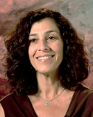
Caren L. Sax, Ed.D., CRC
Phone: (619) 594-7183
Email: csax@mail.sdsu.edu
Dr. Sax is Professor and Chair of the Department of Administration, Rehabilitation, and Postsecondary Education and Co-Director of the Interwork Institute at SDSU. In addition to her teaching responsibilities in the M.S. in Rehabilitation Counseling program and the Ed.D. in Educational Leadership/Community College Leadership Concentration, she administers a graduate-level Certificate in Rehabilitation Technology, which she developed with SDSU’s College of Engineering. Dr. Sax also coordinates the Supported Employment and Transition Specialist Certificate. As Co-Director of the Interwork Institute, Dr. Sax directs over $5 million dollars annually in grants and contracts funded through federal and state resources that address the following areas: removing barriers to employment and increasing self-sufficiency for persons with disabilities; technical assistance and continuing education for state agency and community rehabilitation personnel; systems change efforts to improve school-to-work transition services for students with disabilities as they exit the K-12 school system; coordinating supports and services with military families who have children with developmental disabilities; and professional development activities related to assistive technology and universal design. Dr. Sax conducts training for rehabilitation counselors and administrators, community rehabilitation personnel, special educators, and disability organizations in the US and internationally and has published extensively in the disability field. She started her professional career as a special education and transition teacher in Tucson, Arizona.

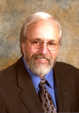
Fred R. McFarlane, Ph.D., CRC
Phone: (619) 594-4228
Email: fmcfarla@mail.sdsu.eduDr. McFarlane is Professor Emeritus and Co-Director of the Interwork Institute at San Diego State University. His vision and leadership skills, along with those of Dr. Ian Pumpian, led in 1990 to the creation of the Interwork Institute.
Dr. McFarlane specializes in the following education content areas: leadership, organizational development, program development, communication skills, ethics, and public policy. He has over 50 publications in referred journals, monographs, and book chapters, with a current focus on public policy, personnel development, and distance education. He is much sought-after as a rehabilitation professional, academic advisor, vocational expert and personal and professional mentor.

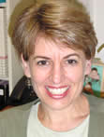
Marjorie F. Olney, Ph.D., CRC
Phone: 619-594-6883
Email: molney@mail.sdsu.eduDr. Marjorie F. Olney’s teaching, research and service activities focus on improving employment opportunities for individuals with psychiatric and developmental disabilities. She is the Program Advisor to the Psychiatric Rehabilitation Certificate and the specialization in Psychiatric Rehabilitation. She has also served as Project Director for the Center for Emerging Leadership (www.interwork.sdsu.edu/cel) and ProjectLEADERS, programs which provide peer-to-peer information, training and mentorship by and for individuals with developmental disabilities.
An active researcher, Dr. Olney uses multiple methodologies to explore disability issues related to identity, service utilization and employment outcomes, and barriers to employment specifically as these impact individuals with cognitive and psychiatric disabilities. She has had 27 peer reviewed articles published, and has presented her work at over 50 local, state and national conferences.
Dr. Olney teaches graduate courses and is a member of the doctoral faculty, co-teaching the seminar in Qualitative Methods of Inquiry each year, and serves on several dissertation committees. She also teaches courses in psychiatric rehabilitation, job placement, foundations of rehabilitation counseling, and counseling theories. Dr. Olney's courses combine theory and practice, demanding critical thinking skills, independence and mutual respect in the classroom.
Dr. Olney encourages lively intellectual exchange of ideas and works to provide a safe and supportive learning environment, motivating students to both apply their learning and to seek more knowledge. In addition to classroom teaching, Dr. Olney regularly provides training to rehabilitation counselors throughout California and its neighboring states on psychiatric disabilities, counseling methods, supported employment and related topics.
Lastly, Dr. Olney serves the community and profession on various university, local, state and national committees and boards. She is an Editorial Board Member for the journals Rehabilitation Counseling Bulletin and conducts peer reviews for several other journals. Dr. Olney is a member of the Workforce, Education and Training committee of San Diego’s Department of Mental Health. She is active in promoting psychiatric rehabilitation within the rehabilitation counseling community through participation in committees with the U.S. Psychiatric Rehabilitation Association (USPRA) and the National Council on Rehabilitation Education (NCRE).She is chair of the Psychiatric Rehabilitation Council of NCRE.
Charles Edmund Degeneffe, Ph.D., CRC, ACSW

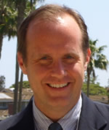

Phone: 619-594-6921
E-mail: cdegenef@mail.sdsu.edu

Charles (Chuck) Edmund Degeneffe completed his Ph.D. in Rehabilitation Psychology at the University of Wisconsin-Madison and joined San Diego State University and the Interwork Institute in August 2005. Chuck’s other academic degrees include a Bachelor’s degree in Social Work from the University of Wisconsin-Milwaukee and a Master’s degree in Social Work from the University of Wisconsin-Madison. Chuck holds the Certified Rehabilitation Counselor and Academy of Certified Social Worker credentials. He has over 14 years experience in direct care residential support, supported employment, and counseling and case management. Chuck’s clinical work has specialized on providing supports to persons with cognitive disabilities, including those with traumatic brain injuries, intellectual disabilities, autistic spectrum disorders, and learning disabilities. Chuck is a Professor and the Coordinator of the San Diego State University Masters in Rehabilitation Counseling Program. He also directs the Specialization and Certificate Programs in Cognitive Disabilities.
Chuck’s primary research interests focus on adjustment and caregiving for family members of persons with traumatic brain injuries, with a secondary focus on professional issues within rehabilitation counseling education. He has published his work in such outlets as Brain Injury, Rehabilitation Psychology, Rehabilitation Research, Policy, and Education, Rehabilitation Counseling Bulletin, the Journal of Rehabilitation, the Journal of Applied Rehabilitation Counseling, and the Australian Journal of Rehabilitation Counselling. Chuck has also presented his research at the annual meetings of the American Psychological Association, the National Council on Rehabilitation Education, the American Rehabilitation Counseling Association, and the Brain Injury Associations of California and Wisconsin.
Chuck is on the Editorial Advisory Board for the journal, Rehabilitation Research, Policy, and Education and is an Ad Hoc reviewer for such journals as Rehabilitation Counseling Bulletin and Rehabilitation Psychology. Chuck is the Past-President of the National Council on Rehabilitation Education and is a former Commissioner for the Commission on Rehabilitation Counselor Certification. He currently serves on the Board of Directors for the Council on Rehabilitation Education, and is past President of the San Diego Brain Injury Foundation. Chuck is originally from the Milwaukee area. He enjoys tennis and bike riding in addition to watching his beloved Green Bay Packers play whenever possible. Chuck, his wife Tamara, and daughter Sophia enjoy the beauty of San Diego and love to travel.

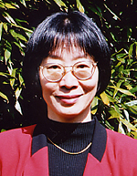
Nan Zhang Hampton, Ph.D., CRC
Phone: 619-594-6425
E-Mail: nhampton@mail.sdsu.edu

Nan Zhang Hampton, Ph.D., C.R.C. is a Professor in the Rehabilitation Counseling Program at San Diego State University. Before joining the RC program at SDSU, Dr. Hampton was an associate professor at University of Massachusetts at Boston and had taught rehabilitation counseling there for the past nine years. She has over 100 publications and presentations in refereed rehabilitation journals, professional conferences, seminars, and workshops, and has a consistent record of service as a consultant to a variety of public school programs, higher education programs, professional organizations, public or private community rehabilitation service agencies, and international organizations. At her leisure time, she enjoys exploring different cultures, gardening, visiting museums, and reading

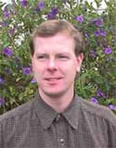
Mark Tucker, Ph.D., CRC
Phone: (619) 594-3498
Email: mtucker@interwork.sdsu.edu

Mark Tucker is an Assistant Professor in the Rehabilitation Counseling Program. For many years, Mark has worked as a Project Manager with the Interwork Institute, with a primary role conducting statewide needs assessment projects for State Vocational Rehabilitation agencies in several U.S. states and territories. Prior to joining SDSU, Mark worked as Program Coordinator for a Southern California-based non-profit agency providing case management, crisis counseling, and vocational planning services. He has experience working with diverse groups and victims of domestic violence. Mark is a Certified Rehabilitation Counselor; he holds a Ph.D. in Human Rehabilitation from the University of Northern Colorado, a Masters Degree in Rehabilitation Counseling from San Diego State University and a Bachelors degree in Psychology from the University of California, San Diego.

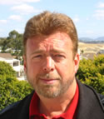
David Noyes, Ed.D., CRC
Email: dnoyes@interwork.sdsu.eduDave's background includes over 15 years of working in various treatment facilities including psychiatric hospitals, day treatment programs, group homes for emotionally disturbed children, and a center for juvenile delinquents. He has been working as a rehabilitation counselor for the last thirteen years, and is currently assigned to a supported employment unit and a transition partnership program. In addition to recent participation as a course Co-Instructor for the Distance Learning program, Dave is also working on a grant project with Interwork at San Diego State University (SDSU) called the "Point of Transition System Integration Project (POTSIP)". Dave is a part-time faculty in the Rehabilitation Counseling Program and has taught the Beginning Practicum Course the past two semesters.
Dave earned his Doctoral degree from the University of San Diego Educational Leadership program in 2002; his Master's degree in Rehabilitation Counseling from SDSU in 1986; and completed the certificate program for Post Employment Training in Rehabilitation Administration, also at SDSU, in 1995.

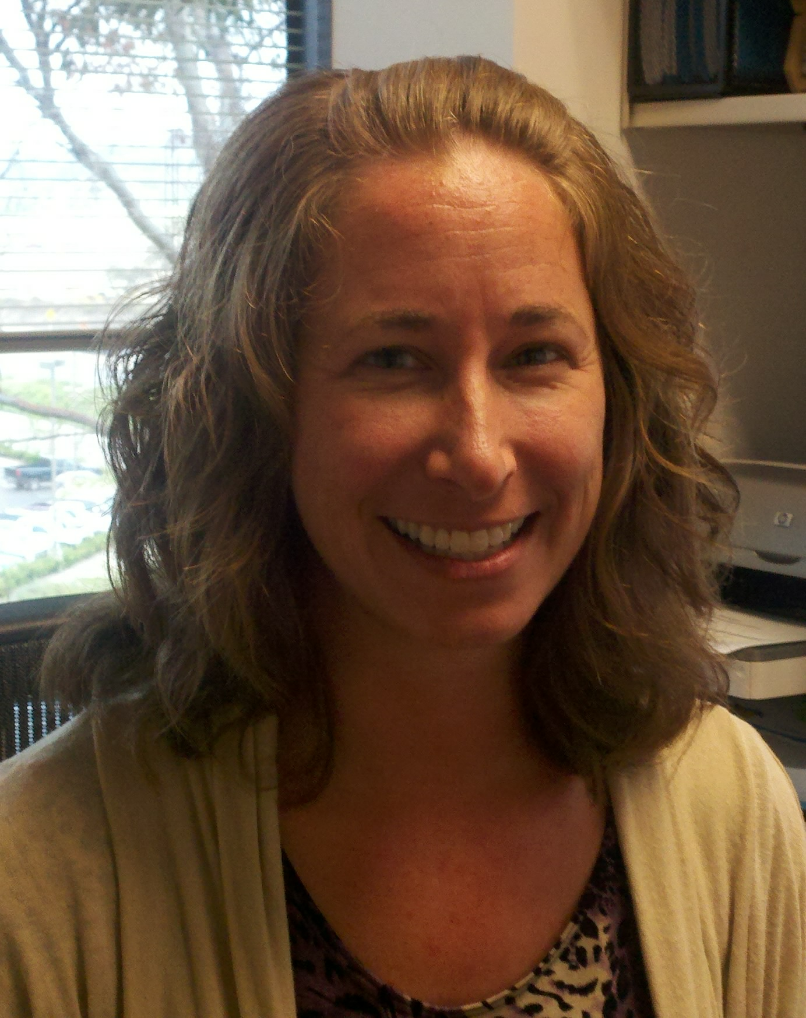
Victoria (Vicki) George, M.S., CRC
Email: gefik@hotmail.com
Vicki George graduated from Ohio University with a bachelor's degree in hearing & speech science and minors in psychology and linguistics. She went on to complete a master's degree in rehabilitation counseling from San Diego State University. Vicki has worked in the field of vocational rehabilitation for over thirteen years, first as an employment specialist for Mental Health Systems, Inc., and since 2008 as a vocational rehabilitation counselor for the Department of Veterans Affairs. In her current position, she is responsible for providing rehabilitation counseling and case management services to Veterans with a wide range of learning, psychological, chronic health and physical disabilities. Vicki has also taught practicum (ARP 744) and co-taught rehabilitation foundations (ARP 684) for the Rehabilitation Counseling Program at SDSU. She is a certified rehabilitation counselor (CRC) and she has recently met the requirements to become a licensed professional clinical counselor (LPCC).
John Filley, M.S.
Email: John.Filley@sdrc.org
John Filley is a part-time adjunct faculty in SDSU’s Rehabilitation Counseling Program. Mr. Filley has worked for over 25 years in disability-related services. For 21 years, he directed and coordinated vocational and direct placement services as part of a community rehabilitation program (CRP). Since May of 2009, he has been working as a Social Work Counselor with the San Diego Regional Center, part of California’s Department of Developmental Services. He is also the Project Director for a grant funded by CECY (California Employment Collaborative for Youth and Young Adults with Disabilities) that is focused on improving employment outcomes for transition-aged youth. Mr. Filley has a Masters degree in Rehabilitation Counseling, as well as a Certificate in Rehabilitation Technology from San Diego State University.
Nelson Wright, M.S., CRC
Email: Nelson.D.Wright@dor.ca.gov
Nelson is retired supervisor from the California Department of Rehabilitation, in the San Diego Regional Office. Nelson teaches internship classes for the Masters program, has supervised interns in a job club program offered through the California Department of Rehabilitation.
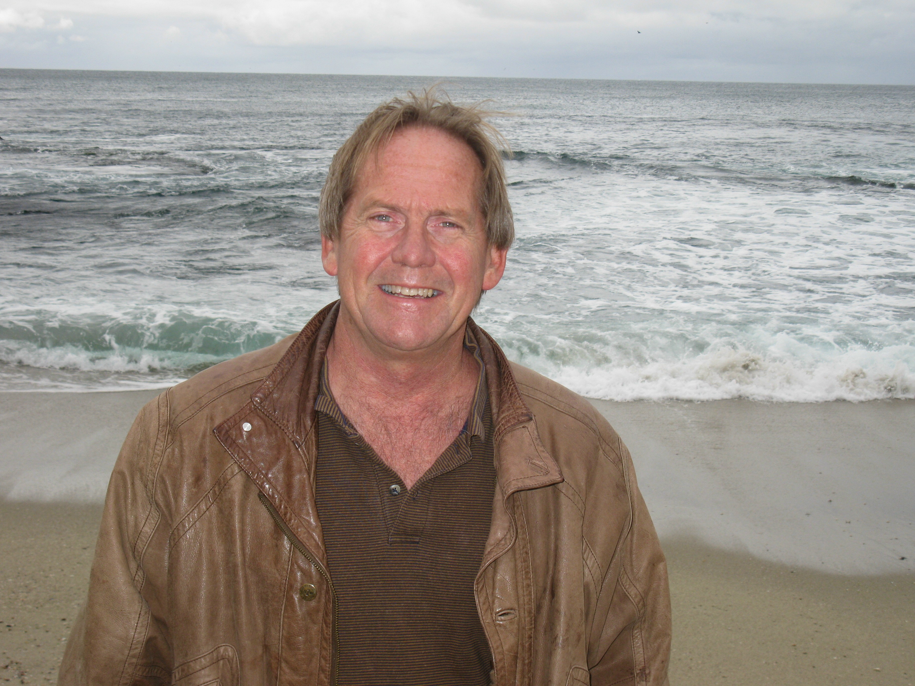
Robert Price M.S., CRC, CPRP, LPCC

Email: rwprice@aznet.net

Robert Price has worked in mental health and vocational rehabilitation for over 20 years. He completed his Bachelors degree in Social Welfare from Humboldt State and went on to work in a variety of community based mental health programs. Robert went on to complete his Masters degree in Rehabilitation Counseling at San Diego State University. He is a Certified Rehabilitation Counselor, as well as a Certified Psychiatric Rehabilitation Practitioner. He is also one of the first SDSU Rehabilitation Counseling graduates to have earned the new Licensed Professional Clinical Counselor designation.

Robert is currently employed as a Rehabilitation Counselor with the State of California Department of Rehabilitation, where he specializes in Mental Health Rehabilitation and Cooperative Programs. Additional specializations include vocational rehabilitation services to individuals residing in Post-Prison Treatment facilities. Robert has been co-teaching the Fall Job Placement course for the Rehabilitation Counseling Graduate program on campus at SDSU since 2008.
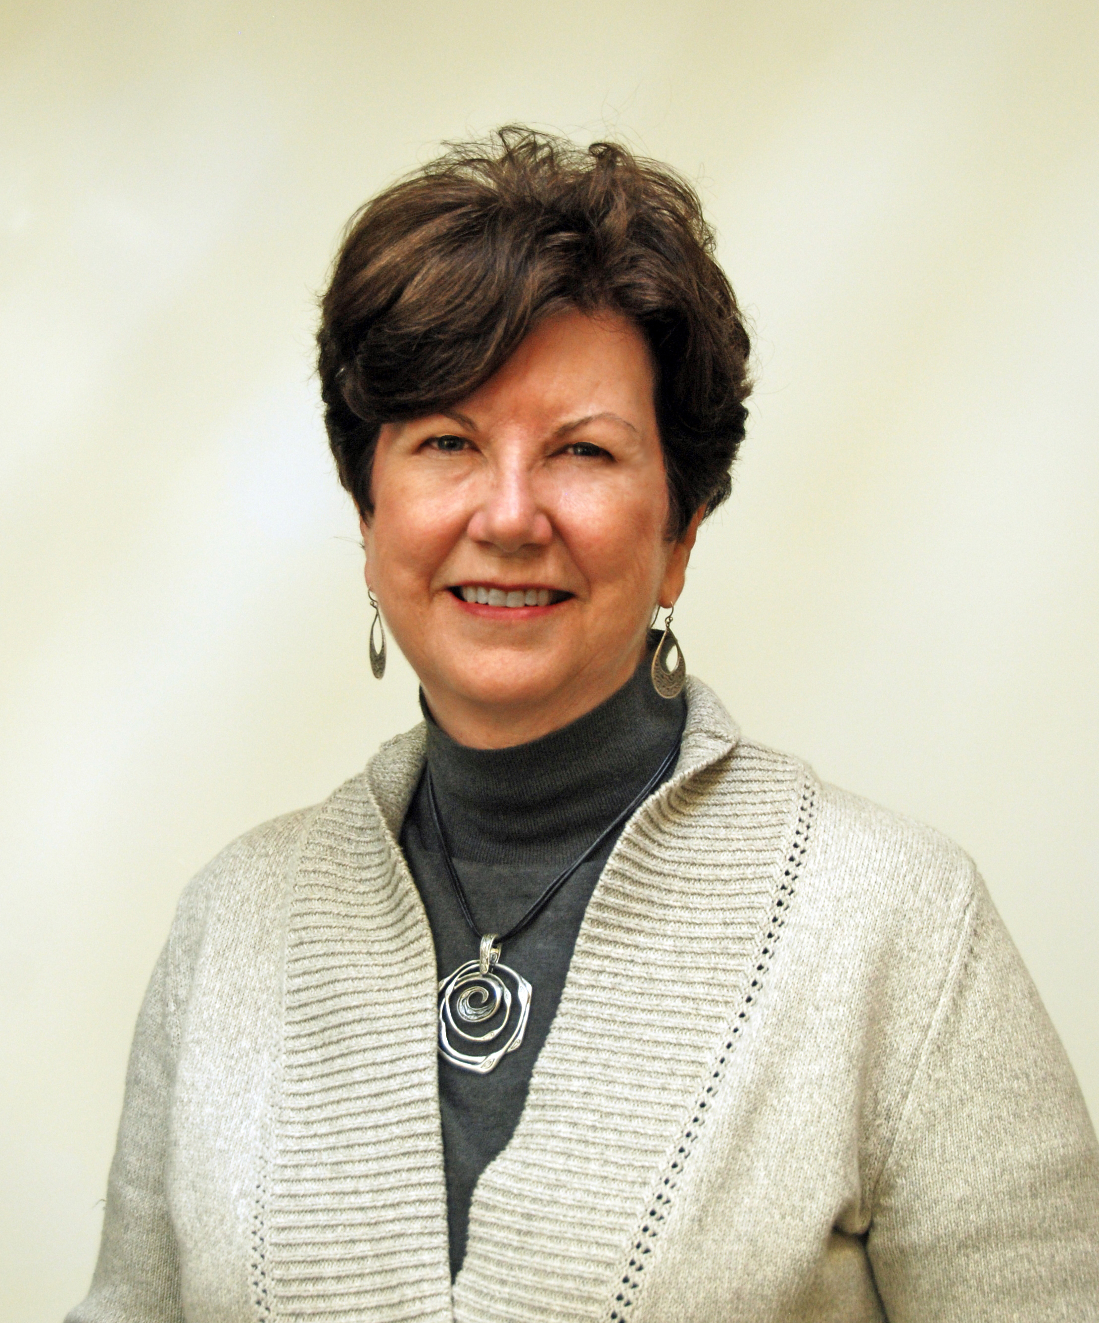
Jill Baker, Ed.D.

Email: jibaker@sdccd.edu

Dr. Jill Baker is Dean of Institutional Effectiveness for San Diego Mesa College. She has been with the College for 12 years. Her primary work involves integrated planning, assessment, evaluation, and resource allocation. Prior to her current assignment, she served as Instructional Dean for the School of Business and Technology. She currently serves as Administrative Co-Chair of the Planning and Institutional Effectiveness Committee and Program Review, and previously served as Faculty Co-Chair and Lead Writer for the 2010 Self Study for Reaffirmation of Accreditation. She has long served on committees related to technology, strategic planning, program review, and institutional effectiveness.

Jill’s educational background includes a Bachelor of Arts in English from University of California, Riverside, a Master of Library Science from San Jose State University, a K-12 Multiple Subject Teaching Credential and Cross-Cultural Language and Academic Development Credential from California State University, San Marcos, and a Doctorate in Educational Leadership, with Community College Emphasis, from San Diego State University.

Jill has researched, published, and presented on culture, change, and leadership, building a culture of evidence, and transparent decision making through integrated planning. She recently collaborated with Dr. Marilee Bresciani on visioning the future of holistic student assessment and the purpose of program review. She has served as an external team evaluator in the areas of institutional effectiveness and technology for the Accrediting Commission for Community and Junior Colleges, a division of WASC. In 2009, as a faculty member, Jill was named Teacher of the Year by the California Association for Postsecondary Education and Disability for her work in assuring accessibility to media and technology and for her commitment to Universal Design.
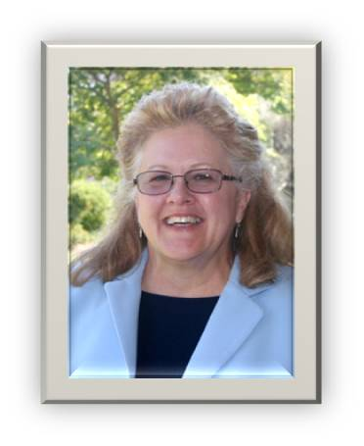
Gail Conrad, Ed.D.
Email: gconrad@sdccd.edu
Dr. Gail Conrad has taught our Grant Writing course for the past four years. She currently works for the San Diego Community College District as the Acting Vice Chancellor for Student Services, which includes City College, Mesa College, Miramar College, and Continuing Education.

She had been the director for Disability Support Programs and Services (DSPS) and has worked in the community colleges for over 25 years. She presently oversees three grants in the DSPS program.
She received a doctorate in 2010 from SDSU's Educational Leadership with an emphasis in Community College, has a MS in Physical Education with an emphasis in Adaptives from Humboldt State University and a BS in Occupational Therapy from San Jose State University.
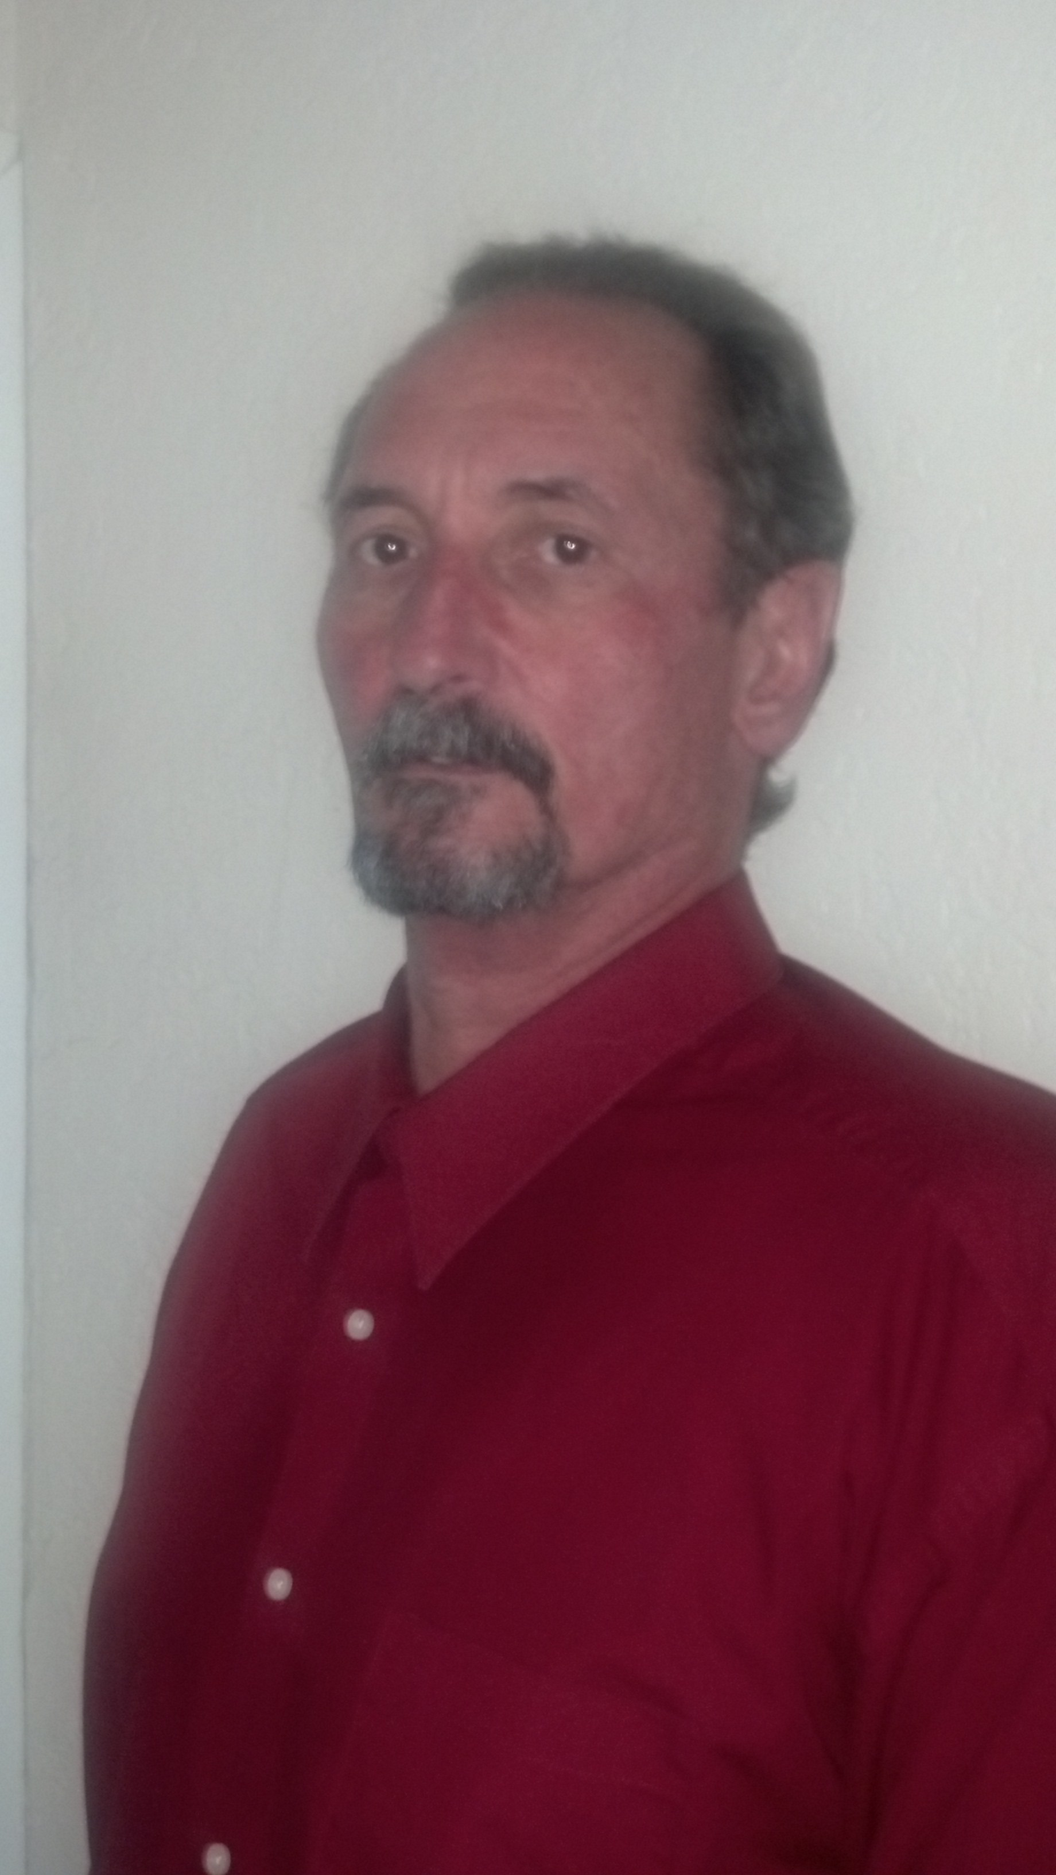
Charlie Aperule M.S., CRC, LAADC, CADC-II, CATC-IVE, CCS
Email: caperule@gmail.com
Charlie Aperule is the Program Manager for Mental Health Systems, Inc’s (MHS) Central East Regional Recovery Center, an outpatient substance abuse treatment program focusing on clients involved in the criminal justice system. He has worked in the substance abuse treatment field for twelve years in San Diego County and has specialized in California’s treatment rather than incarceration programming since 2003. As Program Manager, he has implemented innovative program services to improve treatment retention rates and client sustainability through case management, employment services, and mental health assessments services for participants. Mr. Aperule’s efforts have reduced the recidivism rate for the individuals who have successfully completed treatment at Central East Regional Recovery Center. In addition, Mr. Aperule is a member of MHS’s Co-Occurring Guide team, a company trainer for Co-Occurring Disorders, and a member of San Diego County’s 2009 CADRE. He has a Bachelor’s degree in Psychology, certified CADC-II alcohol and drug abuse counselor, and Master of Science in Rehabilitation Counseling with a specialization and Certificate in Psychiatric Rehabilitation from San Diego State University. Mr. Aperule has experience as a teacher and trainer which includes San Diego City College Adjunct Professor, Behavioral Sciences/Alcohol and Other Drug Studies, as well as Adjunct Facility at San Diego State University’s Rehabilitation Counseling Program teaching Intermediate Practicum. Mr. Aperule has also been a guest teacher in the private certification schools in San Diego County.

