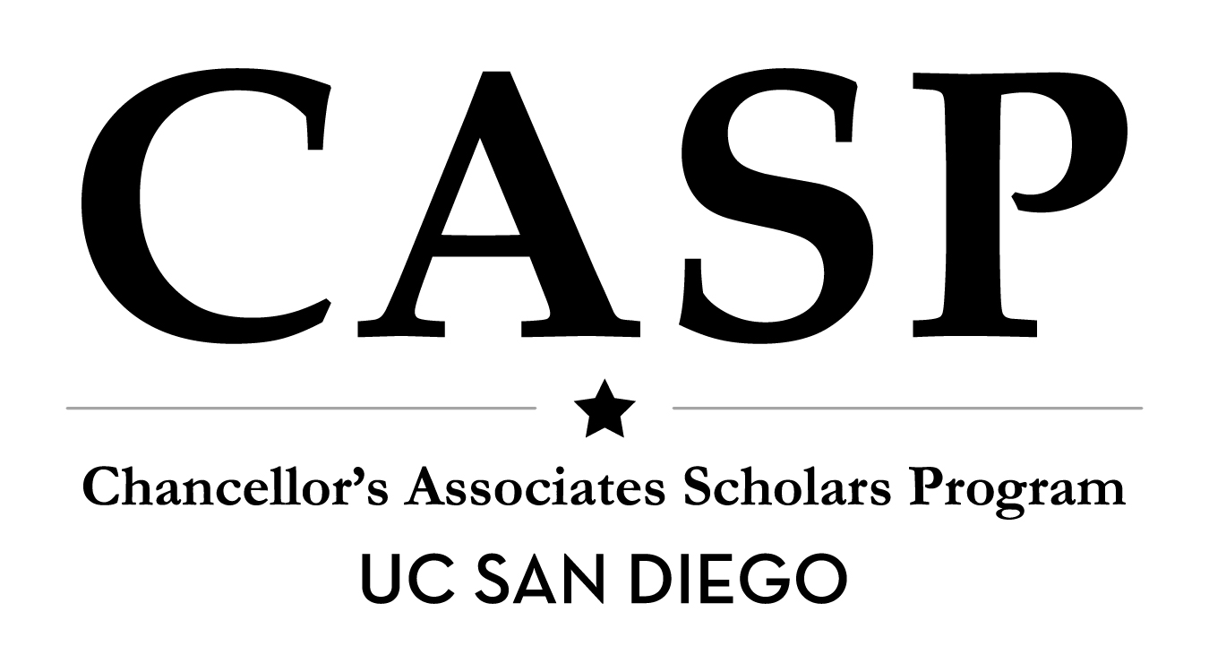
SAN DIEGO STATE UNIVERSITY GRADUATE ASSISTANTSHIP
POSITION DESCRIPTION

POSITION INFORMATION
JOB TITLE Chancellor’s Associates Scholars Program (CASP) Graduate Assistant
DEPARTMENT Office of the VC – Student Affairs
SUPERVISOR Program Manager, CASP
DEPARTMENT CONTACT Belinda Zamacona | (858) 822-6740 | belinda@ucsd.edu

OFFICE OF THE VC - STUDENT AFFAIRS
Student Affairs contributes to UC San Diego undergraduate and graduate students’ holistic development by
supporting important services and programs. The Vice Chancellor – Student Affairs has oversight for a wide array of
programs across student affairs including, but not limited to: academic enrichment, career services, recreation,
health and wellness, international education, admissions/enrollment services, and athletics.
The CASP program is located within the Office of the Vice Chancellor – Student Affairs. This position will report to
the CASP Program Manager.

CASP OFFICE
In 2013, Chancellor Pradeep Khosla created a new undergraduate scholarship program, the Chancellor’s
Associates Scholars, to recognize and support local, high-achieving, and talented students who:
- Have been admitted to UC San Diego
- Are California residents
- Have demonstrated financial need and family incomes of $80,000 or less

The Chancellor’s Associates Scholars Program (CASP) was created to accompany the scholarship and to support admitted scholars throughout their time at UC San Diego. The program represents UC San Diego's full commitment to support and develop scholars through graduation; it provides a wide range of services and opportunities to ensure that they thrive as UC San Diego undergraduate students, and are fully engaged in academics, student life, and university experiences.

EDUCATIONAL OBJECTIVES
The CASP Graduate Assistant (GA) will work under the direct supervision of the CASP Program Manager. This assistantship will provide an opportunity for the incumbent to learn and practice her or his skills in coordinating retention efforts, programs and services for high academic achieving, first generation, low-income students. As of Fall 2014, the CASP student body is made up of 117 undergraduate students, some of whom are transfer students.

The CASP GA will support the following components of the CASP program:
- Program Coordination
- Assessment
- Student Engagement & Development

Programs coordination may include: summer transition program, internship-readiness initiatives, guest faculty presentations, peer mentorship program, program marketing, and student engagement events & activities. Additionally, the GA will be involved in furthering campus-wide collaboration through campus and community partnerships.

Program assessment may include: quarterly program assessment, peer mentor assessment, overall program satisfaction assessment.

Student Engagement & Development - The GA will have the opportunity to engage students in communication skills development, leadership strategies, program development, student advising, organization and project management best practices, basic supervisory skills, assessment skills, and insight into student affairs work at a large, public university.

The GA will meet regularly with her or his supervisor to discuss progress and development. Opportunities for formal assessment will be offered for the purpose of providing her or him with feedback on observed growth and learning.

DUTIES AND RESPONSIBILITIES
- Coordinate CASP programs, events, and services
- Evaluate learning outcomes for students participating in programs or opportunities
- Conduct research and assess the needs and interests of CASP students
- Provide administrative support for the CASP office
- Market and promote programs, information, and services related to CASP

LEARNING OUTCOMES & ARTIFACTS
To be determined upon placement.

REQUIREMENTS
- Must have/maintain a 3.00 cumulative GPA for graduate courses during employment.
- Must be enrolled in at least 6 units in a student personnel or related program during the academic year.
- Must demonstrate commitment and follow-through on projects.
- Must be detail-oriented, organized, communicative and dependable.
- Must have strong written and oral communication skills.
- Must have an interest and/or knowledge of working with a diverse student population.
- Must have an interest and/or knowledge of student development theory.
- Must have an interest and/or knowledge of working with first generation students.

KNOWLEDGE AND SKILLS NEEDED
- Ability to work in a team environment and independently.
- Strong organizational and planning skills with attention to detail.
- Must have the ability to interact with diverse students and staff with equity and civility.
- Must demonstrate ability to assess student learning outcomes and prepare reports.
- Ability to reason logically, draw valid conclusions, and make appropriate recommendations.
- Preference for having some knowledge of program evaluation, data systems, and analysis.
- Strong familiarity with Excel, Word, PowerPoint.

BENEFITS
- Experience in a high profile, high visibility student affairs office.
- Experience in student affairs programming for first-generation students.
- Professional mentoring relationships with student affairs and academic staff.
- Opportunity for personal growth and professional experiential enrichment.
- Experience in evaluating student learning outcomes and determining areas for development.
- Acquaintance to university administration at a large, research, public institution. Introduction to dedicated student affairs professionals, faculty, and campus resources.
- Rewards of making a positive impact on a diverse array of programs and services

ADDITIONAL INFORMATION
Additional information on the CASP program can be found on http://casp.ucsd.edu, or on social media at http://facebook.com/caspUCSD and http://twitter.com/ucsdcasp.

