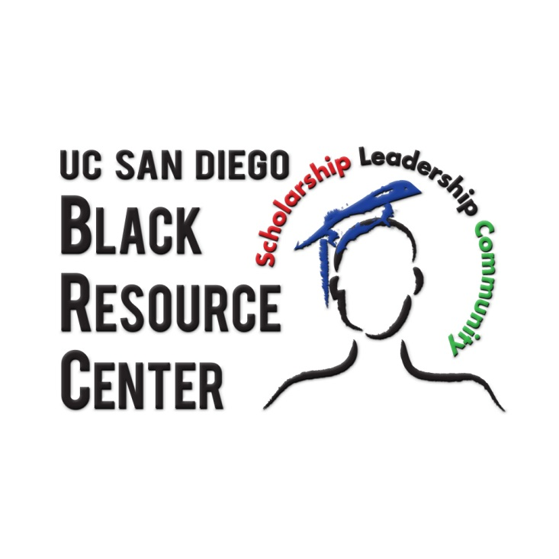
UC SAN DIEGO
BLACK RESOURCE CENTER
GRADUATE STUDENT GRADUATE ASSISTANT
POSITION DESCRIPTION FOR 2015-2016

- Position Information
Job Title: Black Resource Center Graduate Student Assistant
Department: Black Resource Center
Supervisor: Director, Black Resource Center

- Black Resource Center:
Established in 2013, the Black Resource Center (BRC) is a Campus Community Center which serves the entire population of UC San Diego while emphasizing the Black experience. Birthed through strong advocacy of students, alumni and other supporters, the BRC seeks to provide support services and foster community for current undergraduate and graduate students. Services include but are not limited to: academic support services, mentoring/leadership development, co-and extra-curricular programming, and non-academic counseling. In addition to the student services, the center is positioned as a resource for alumni, faculty, staff and the community at-large.

The BRC is not intended to be duplicative but will leverage existing resources and bring them together in a single location thus creating a sense of place and community and providing an important support system particularly for African and African American students on campus.

- Educational Objectives:
Under the leadership & direct supervision of the Director, the Black Resource Center, the Graduate Assistant will have the opportunity to assist in the facilitation of projects originating in the Black Resource Center as well as projects from the office of the Vice Chancellor for Equity, Diversity and Inclusion, as assigned. Specifically, the Graduate Assistant will work on projects which aide in the outreach, recruitment, retention and yield of historically underrepresented students. The appointment is for one academic year, 2014 – 2015.

- Duties and Responsibilities:
- Oversee and provide leadership for peer to peer mentoring program for historically underrepresented undergraduate students at UC San Diego
- Develop and facilitate workshops/programs which will aide in the holistic success of historically underrepresented students. Topics to be centered around academic support, social development, leadership skills and professional growth. These workshops/programs may be done in collaboration with other campus units such as OASIS, Career Services, LGBT Resource Center, Cross Cultural Center, Women’s Center, Raza Resource Centro, UCSD Alumni, etc.
- Assist in the development, organization and facilitation of major campus-wide yield events such as the annual Overnight Program which targets admitted students
- Assist in the development, organization and facilitation of annual student recognition events such as the First Year Student Award Program & Black Grad
- Participate in student outreach efforts within the local San Diego community
- Foster relationships with campus units and colleges to create a greater sense of community for targeted students
- Attend and participate in staff meetings and staff development opportunities when schedule permits
- Assist with Black Resource Center social media presence (Facebook, Twitter, etc.)
- Assist in data collection & on-going research review specifically for targeted population which will be used to inform work of the Black Resource Center
- Other duties as assigned

- Learning Outcomes and Artifacts:
Will be determined upon placement

- Requirements:
- Must be enrolled in at least 6 units in a student personnel or related program at San Diego State University
- Available to work evenings and weekends as necessary for special events/programs
- Knowledge of student development theory specifically as it pertains to success strategies for historically unrepresented students, in general & African American students, in particular
- Demonstrated cultural competence in working with students from diverse backgrounds
- Strong verbal and written communication skills

- Knowledge and Skills
- Ability to work in a team environment and independently.
- Ability to prioritize job tasks and responsibilities.
- Ability to reason logically, draw valid conclusions and make appropriate recommendations.
- Must have the ability to interact with diverse students, families, and staff with equity and civility.
- General knowledge of qualitative and quantitative research methods and methodology preferred.
- Working knowledge of equity, diversity and inclusion as it pertains to higher education
- Strong familiarity with Excel, Word, PowerPoint, preferred experience with online resources (i.e. Google Calendar, Documents) and survey software.

BENEFITS
- Experience in a high profile, high visibility, new Campus Community Center
- Familiarity with UC San Diego campus resources, faculty, staff, and administrators.
- Experience in collecting and analyzing research.
- Opportunity for personal growth and development.
- Rewards of making a positive impact on diversity programs and services

Contact Information
Stacia Smith Solomon
Director, Black Resource Center
Vice Chancellor – Equity, Diversity & Inclusion
9500 Gilman Drive, 0092
La Jolla, CA 92093
(858) 534-0471
sssolomon@ucsd.edu

